
INDUSTRY REPORT
Professional, Scientific and Technical Services in the US
Mar 2026

About

IBISWorld
IBISWorld specializes in industry research with coverage on thousands of global industries. Our comprehensive data and in-depth analysis help businesses of all types gain quick and actionable insights on industries around the world. Busy professionals can spend less time researching and preparing for meetings, and more time focused on making strategic business decisions.

Table Of Contents | Standard

1. About 4
Codes 4
Definition 4
Related Terms 4
What's Included 4
Related Industries 5
Additional Resources 5
2. At a Glance 6
Key Takeaways 6
Products and Services 7
Major Players 8
Key External Drivers 9
Industry Structure 9
SWOT 10
Executive Summary 10
3. Performance 12
Highlights 12
Key Takeaways 12
Performance Snapshot 13
Outlook 22
Life Cycle 25
4. Products and Markets 26
Key Takeaways 26
Products and Services 26
Major Markets 32
International Trade 34
5. Geographic Breakdown 35
Key Takeaways 35
Business Locations 36
6. Competitive Forces 41
Key Takeaways 41
Concentration 41
Barriers to Entry 42
Substitutes 43
Buyer & Supplier Power 45
7. Companies 47
8. External Environment 48
Key Takeaways 48
External Drivers 48
Regulation & Policy 52
Assistance 54
9. Financial Benchmarks 55
Key Takeaways 55
Cost Structure 55
Key Ratios 59
10. Key Statistics 61
Industry Data 61

1. About
https://my.ibisworld.com/us/en/industry/54/about

Codes
NAICS 2017 - USA | 54
NAICS 2022 - USA | 54

Definition
This sector is primarily engaged in the undertaking of professional, scientific or technical services. Operators in this sector require a high degree of expertise and training in their chosen field. Operators in this sector then offer these services to a range of end user industries and household consumers.

Related Terms

AUDITING
The act of reviewing a company's financial operations to ensure regulatory compliance.

MANAGEMENT CONSULTANT
A consultant who provides advice and assistance to businesses and other organizations on various issues, including management.

INFORMATION TECHNOLOGY (IT)
The design, development, implementation, support or management of computer-based information systems.

BIG DATA ANALYTICS
The method by which a company combs through a large collection of unorganized data for potential trends and insights.

OUTSOURCE
To procure goods or services under contract with an outside supplier.

NONEMPLOYER ESTABLISHMENT
A sole proprietor or partnership with no payroll employees.

What's Included
- Legal services
- Accounting, tax return preparations, bookkeeping and payroll services
- Architectural, engineering and related services
- Specialized design services
- Computer systems design and related services
- Management, scientific and technical consulting services
- Scientific research and development
- Advertising and related services
- Other professional, scientific and technical services

Related Industries

Industries in the Same Sector
- Competitors:
  - No data available
- Complementors:
  - Information in the US
  - Educational Services in the US

International Industries
- No data available

Additional Resources
- US Census Bureau
- Computing Technology Industry Association
- Information Technology Industry Council
- American Institute of CPAs
- American Bar Association
- Institute of Management Consultants USA

2. At a Glance
https://my.ibisworld.com/us/en/industry/54/at-a-glance
Revenue  $3.3tr  ’21-’26 ↑ 1.5 %  ’26-’31 ↑ 1.9 % | Employees  15m  ’21-’26 ↑ 2.4 %  ’26-’31 ↑ 1.9 % | Businesses  5m  ’21-’26 ↑ 2.1 %  ’26-’31 ↑ 1.9 %
Profit  $758.8bn  ’21-’26 ↑ 1.3 % | Profit Margin  23.1%  ’21-’26 ↓ 0.2 pp | Wages  $1.3tr  ’21-’26 ↑ 1.2 %  ’26-’31 ↑ 1.9 %

Key Takeaways

Performance
- The sector expanded amid economic headwinds. Heightened inflationary pressures, interest rate hikes and new policies like OBBBA expanded professional services growth across niches such accounting, law and consulting. Lucrative services across technology and scientific research enhanced sector-wide performance.
- Technological advancements will bolster sector performance. A higher frequency of government contracts and a rebound in nonresidential construction will drive demand in various subsectors with high technical innovation.

Products and Markets
- Corporate profit growth is driving increased demand among business clients. Rising national GDP and higher corporate profit generates greater business interest in professional and technical services.
- Macroeconomic growth benefited the professional and technical services sector overall. However, some subsectors, such as architectural and engineering services, contracted amid elevated interest rates and an uneven housing market.

Products and Services
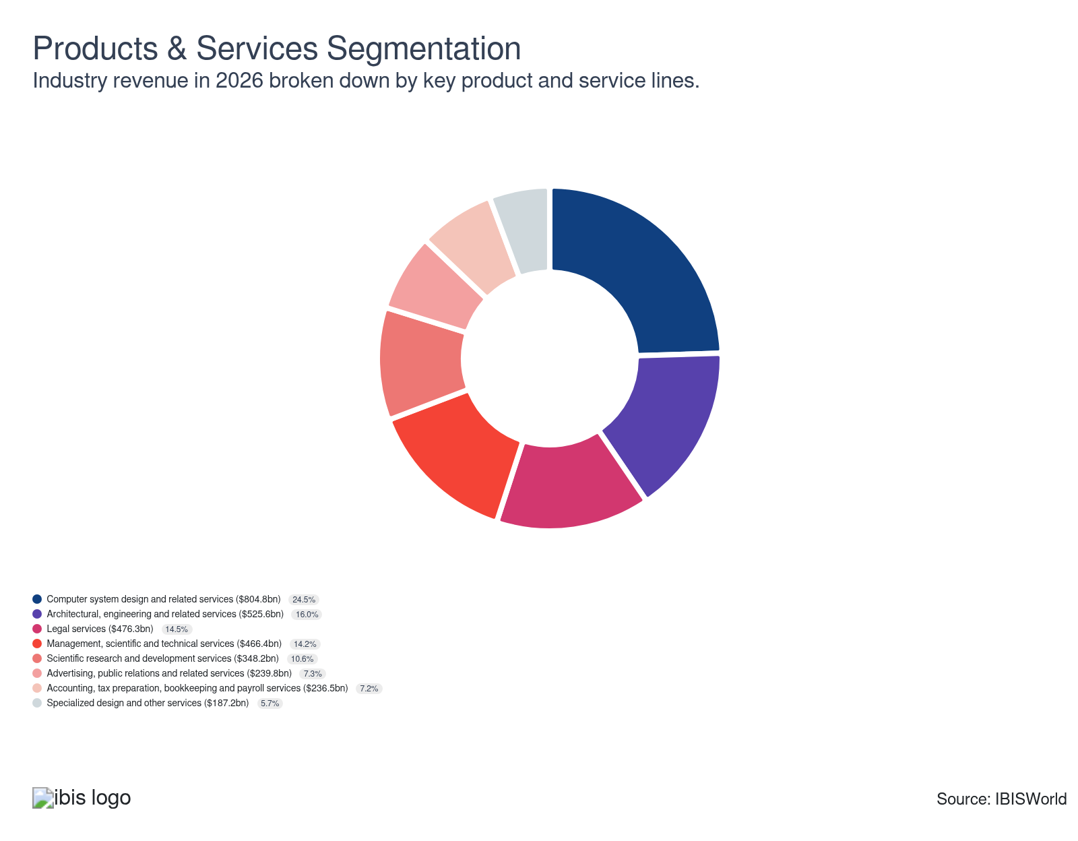

Major Players
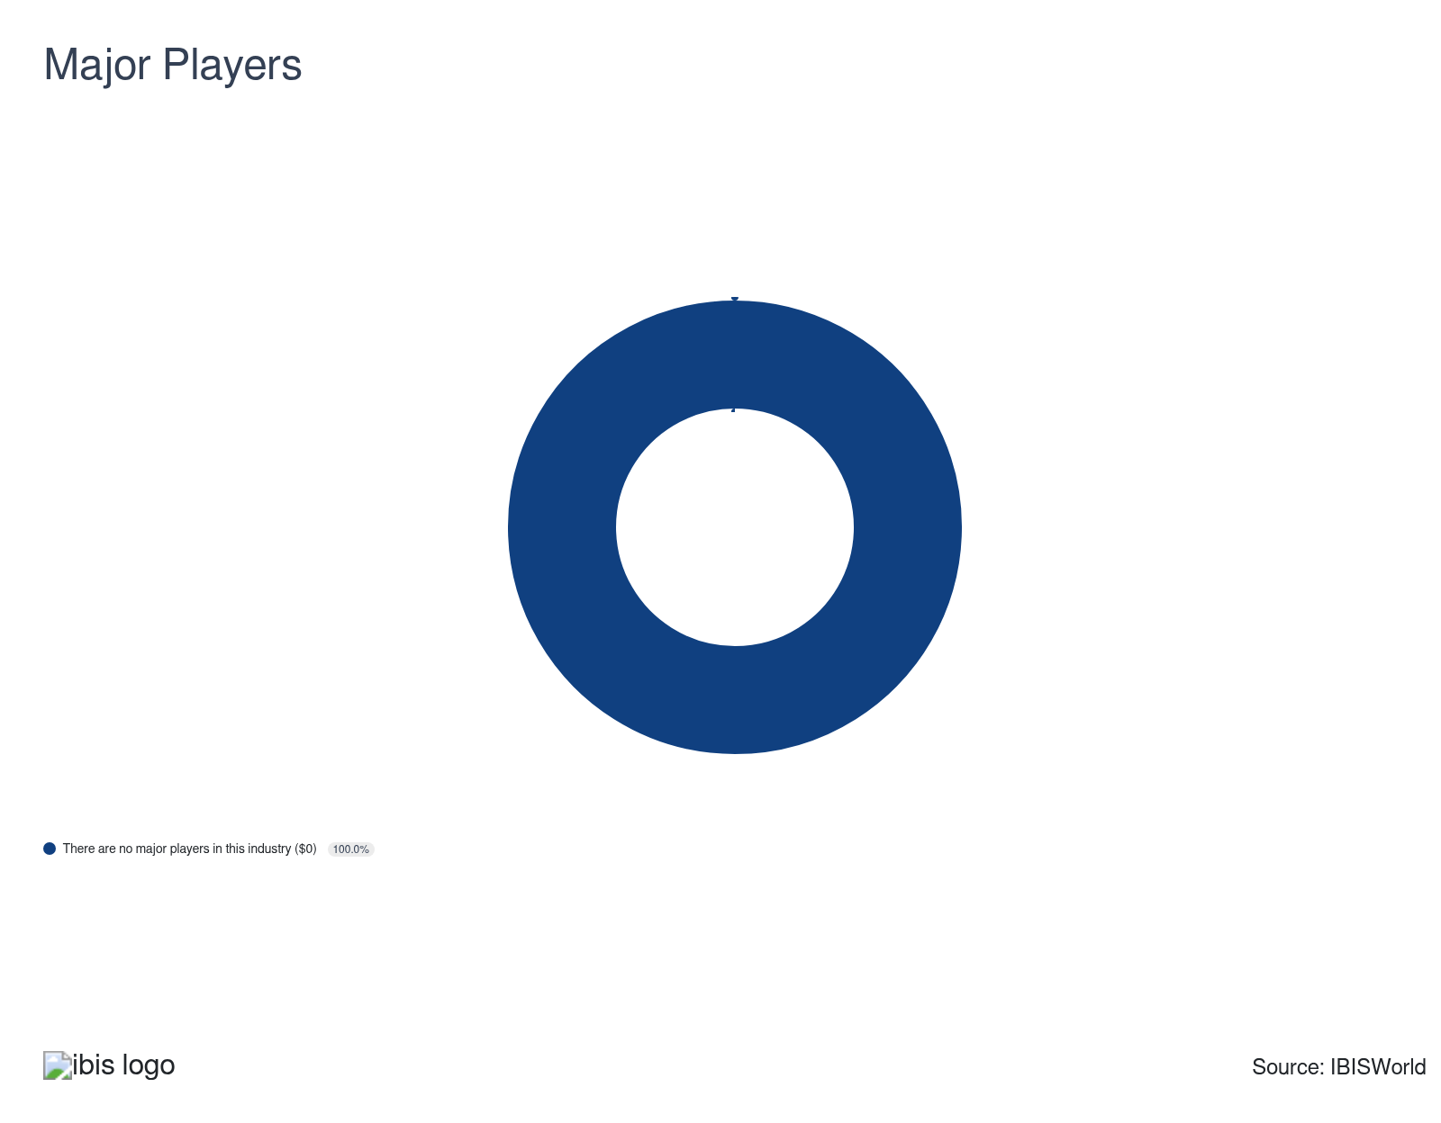

Key External Drivers
Key External Drivers | Impact
US Gross domestic product (GDP) | Positive
Per capita disposable income | Positive
Total advertising expenditure | Positive
Value of residential construction | Positive
Value of private nonresidential construction | Positive
Investor uncertainty | Negative

Industry Structure
Characteristic | Level | Trend
Concentration | Low
Barriers To Entry | Low | Steady
Regulation and Policy | Low | Increasing
Life Cycle | Mature
Revenue Volatility | Low
Assistance | Low | Steady
Competition | High | Increasing
Innovation | Moderate

SWOT
Strengths  Low Volatility  Low Product/Service Concentration  Low Capital Requirements | Weaknesses  Low Profit vs. Sector Average  High Customer Class Concentration  Low Revenue per Employee | Opportunities  High Revenue Growth (2020-2025)  High Revenue Growth (2025-2030)  High Performance Drivers  Total advertising expenditure | Threats  Low Revenue Growth (2005-2025)  Low Outlier Growth  Investor uncertainty

Executive Summary

Trusting the experts: Continued trends in digital proliferation and emphasis on strategic planning will drive substantial sector demand
Professional, scientific and technical services grew steadily even amid macroeconomic volatility and higher in-house competition. The need for quality, proficient and well-versed services in field such as corporate law were significant drivers of sector demand. Businesses sought out expert services to address core issues such as tax guidance, boosting sector growth amid OBBBA passage in July 2025. While inflationary spikes, which peaked at 9.1% in 2022 per the BLS, curtailed demand within the construction sector, this trend began to show reversal in recent years. Three quarter-point rate cuts in 2025 brought the national interest rate to 3.6% as of January 2026 and provided critical respite to the construction space. Architects, engineers, lawyers and interior designers enjoyed rebounding design and legal service interest across the residential and commercial spaces. Revenue grew at a CAGR of 1.5% to an estimated $3.3 trillion over the past five years, including an estimated 0.8% boost in 2026 alone. Profit remains stable for the sector, although challenges in navigating new tariffs curtailed growth.
Cloud computing and data analytics bolstered sector performance, prompting downstream businesses to hire consultants to upgrade outdated systems. Downstream markets’ attraction to these services has driven growth for IT consultants and management consultants. IT systems have become more prevalent as more consumers and businesses continue to embrace digitization and hybrid work conditions. According to Gallup, 52% of office workers worked in a hybrid environment as of November 2025. Digital media has continued to shake up industries offering advertising-related services, as more emphasis is being placed on digital advertising to reach a wider range of downstream customers. The sector has also evolved as the Environmental, Social and Governance (ESG) changes have become central in guiding broader investment standards, facilitating higher specialization across business-facing industries such as lawyers and accountants.
Moving forward, higher government spending will provide consistent demand for a range of construction-oriented professionals in the fields of new infrastructure projects and scientific R&D initiatives in areas like renewable energy. Ongoing evolution in technological adoption, globalization and environmental needs will drive growth for professional niches specializing in digital implementation, advertising and auditing. Servicers, such as advertisers, architects and engineers will begin adopting new innovations such as artificial intelligence (AI) and Blockchain to improve efficiencies. Revenue is expected to grow at a CAGR of 1.9% to an estimated $3.6 trillion over the next five years.

3. Performance
https://my.ibisworld.com/us/en/industry/54/performance

Highlights
Revenue  $3.3tr  2021-26 CAGR ↑ 1.5 %  2026-31 CAGR ↑ 1.9 % | Employees  15m  2021-26 CAGR ↑ 2.4 %  2026-31 CAGR ↑ 1.9 % | Businesses  5m  2021-26 CAGR ↑ 2.1 %  2026-31 CAGR ↑ 1.9 %
Profit  $758.8bn  2021-26 CAGR ↑ 1.3 % | Profit Margin  23.1%  2021-26 CAGR ↓ 0.2 pp

Key Takeaways
- The sector expanded amid economic headwinds. Heightened inflationary pressures, interest rate hikes and new policies like OBBBA expanded professional services growth across niches such accounting, law and consulting. Lucrative services across technology and scientific research enhanced sector-wide performance.
- Technological advancements will bolster sector performance. A higher frequency of government contracts and a rebound in nonresidential construction will drive demand in various subsectors with high technical innovation.

Performance Snapshot
Revenue: | ↑ 2021-26 Revenue CAGR +1.5%
Revenue  $3.3tr  ’21-’26 ↑ 1.5 %  ’26-’31 ↑ 1.9 % | 2026 Revenue Growth  ↑ 0.8 % | Revenue Volatility  Low
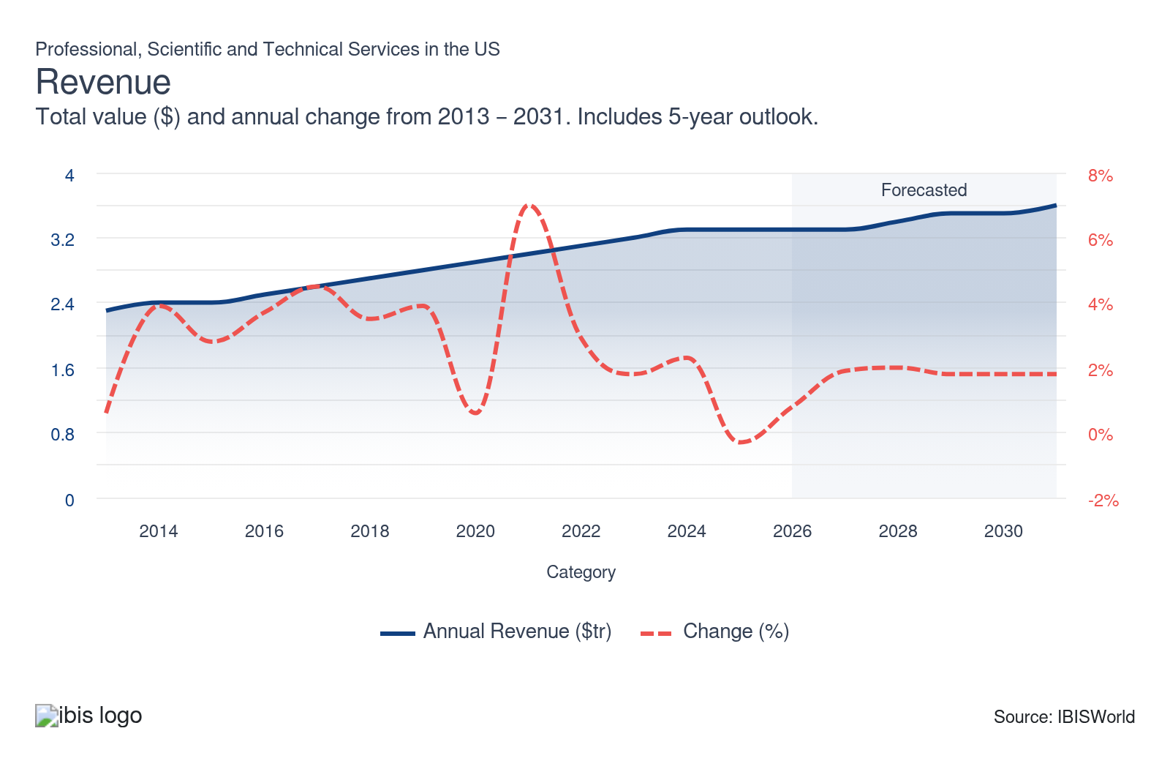
Employees: | ↑ 2021-26 Employees CAGR +2.4%
Employees  15m  ’21-’26 ↑ 2.4 %  ’26-’31 ↑ 1.9 % | Employees per Business  3  ’21-’26 ↑ 0.3 %  ’26-’31 ↓ 0.0 % | Revenue per Employee  $218k  ’21-’26 ↓ 0.9 %  ’26-’31 ↓ 0.0 %
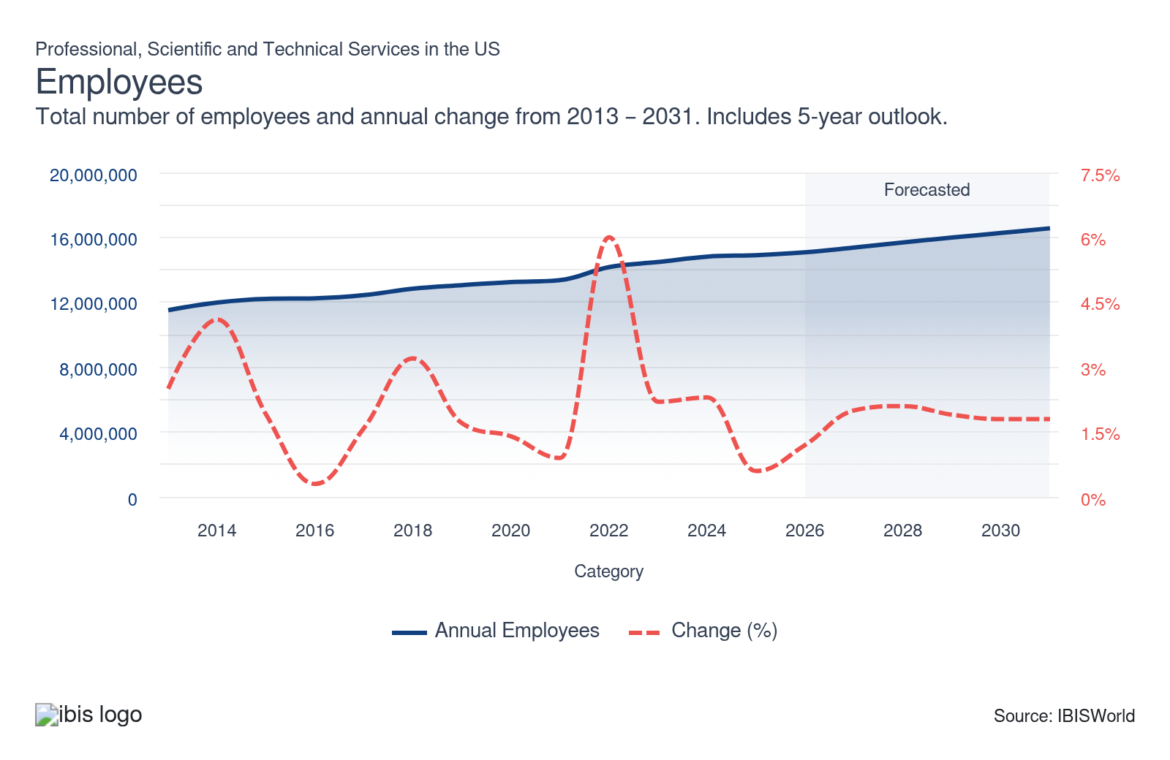
Businesses: | ↑ 2021-26 Business CAGR +2.1%
Businesses  5m  ’21-’26 ↑ 2.1 %  ’26-’31 ↑ 1.9 % | Employees per Business  3  ’21-’26 ↑ 0.3 %  ’26-’31 ↓ 0.0 % | Revenue per Business  $630.5k  ’21-’26 ↓ 0.6 %  ’26-’31 ↓ 0.0 %
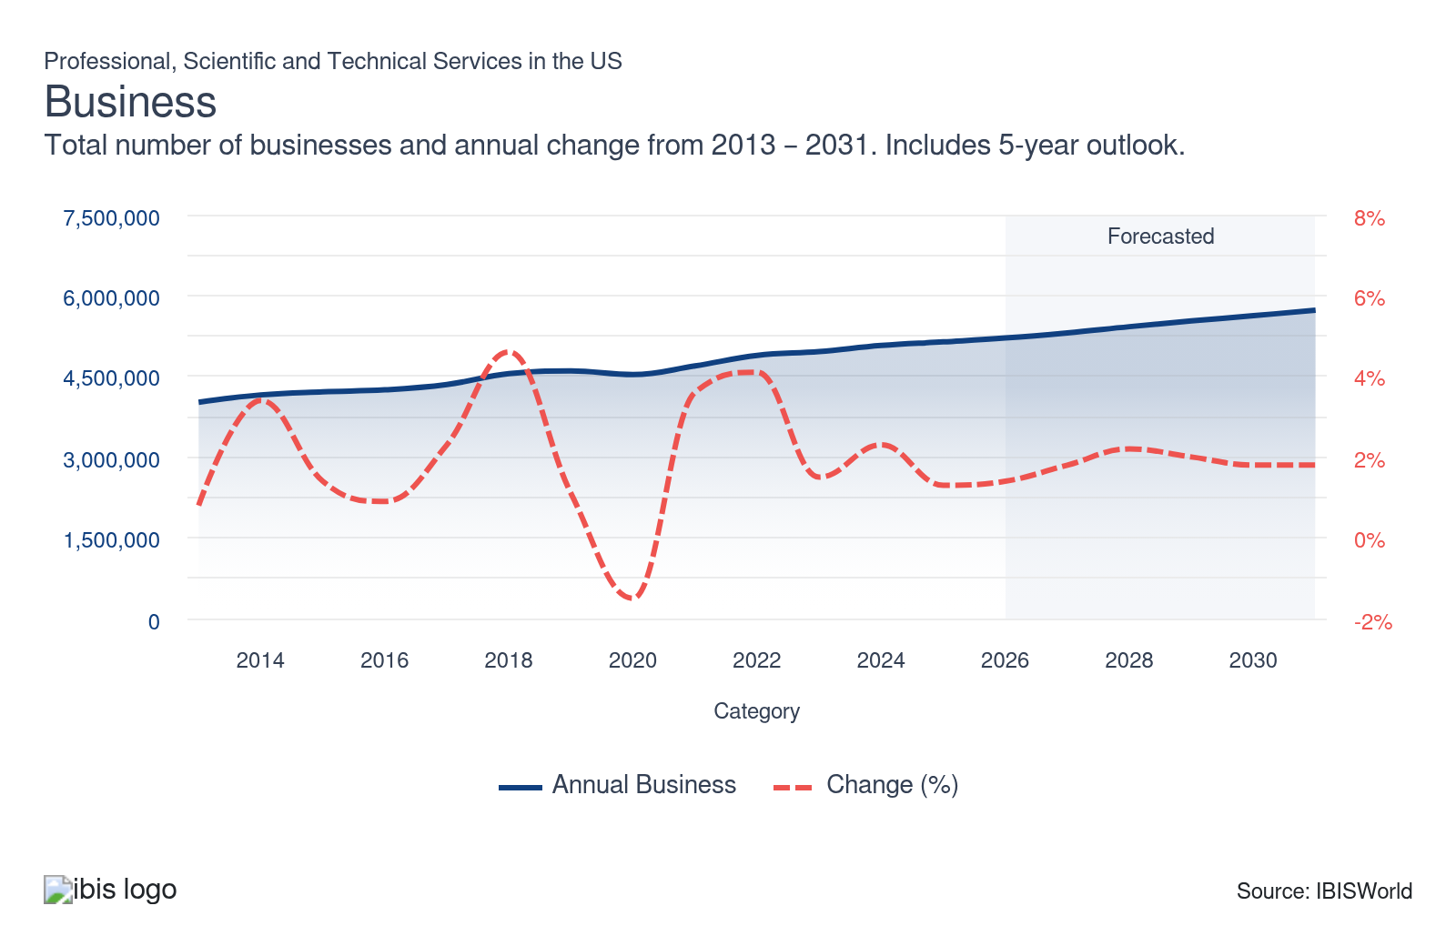
Profit: | ↑ 2021-26 Profit CAGR +1.3%
Total Profit  $758.8bn  ’21-’26 ↑ 1.3 % | Profit Margin  23.1%  ’21-’26 ↓ 0.2 pp | Profit per Business  $145.7k
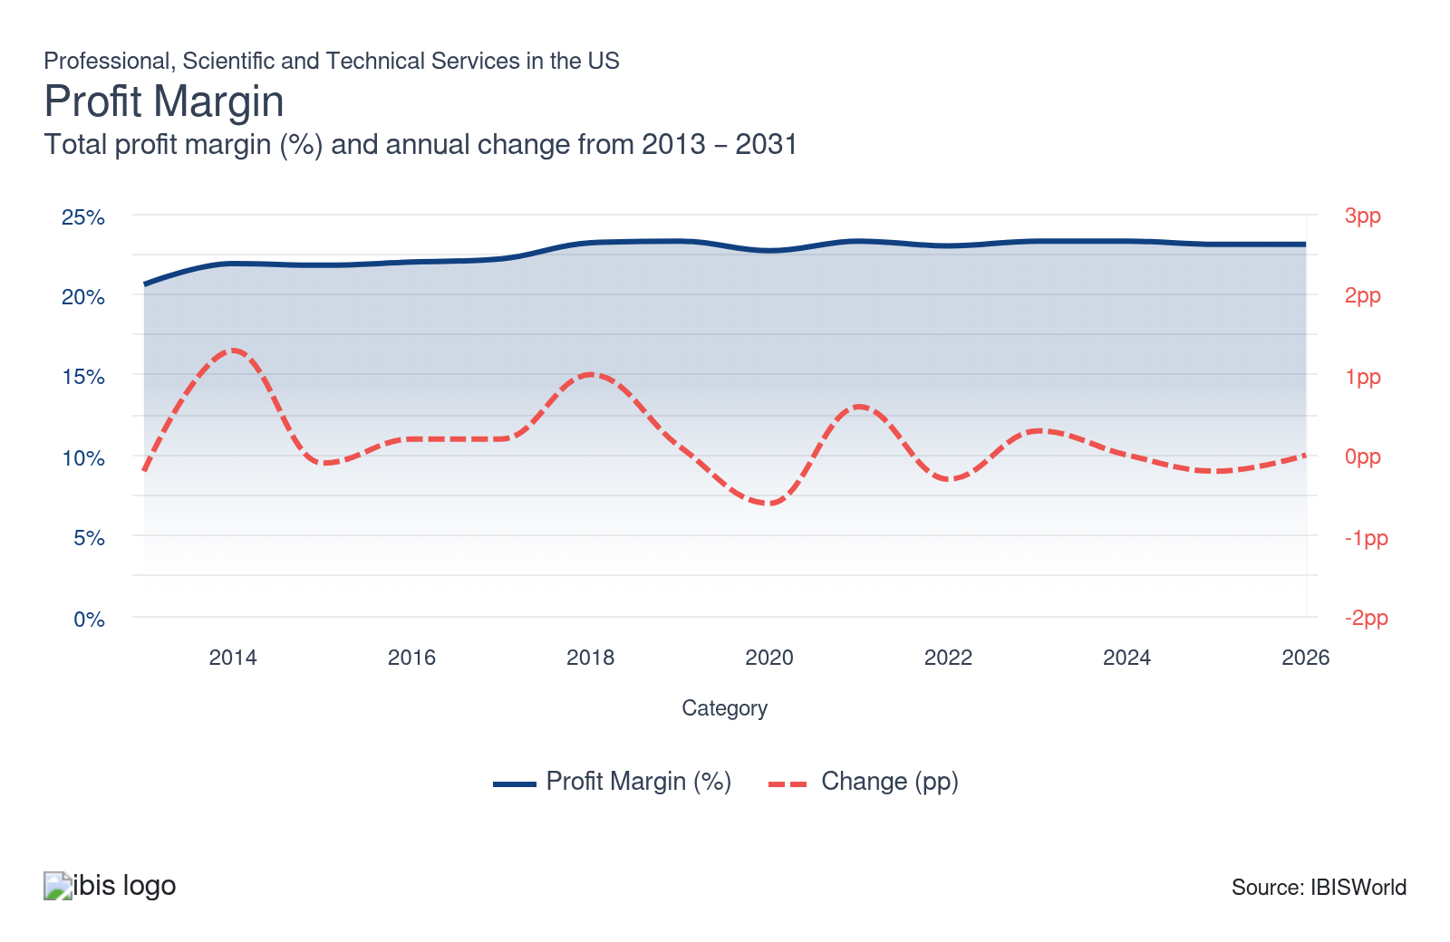
Current Performance
Current Performance

What's driving current industry performance?

A rapidly evolving national economy drives consistent client interest in professional and technical services
- The professional, scientific and technical services sector benefited from continued evolution in macroeconomic conditions. Throughout the sector, clients are heavily dependent on macroeconomic stability to pursue sector services. Economic decline, such as a measured fall in national GDP or per capita disposable income, curtails client interest in sector services, as they have lower capital availability to pursue discretionary services that can be easily substituted, such as interior design or digital advertising.
- Despite sharp economic volatility fueled by high inflation in 2022 and interest rates spiking to a 5.3% high in 2023, the sector was able to weather the storm amid its diversified array of service offerings. Many technical services, such as public relations (PR) firms, benefited from a 1.5% boost in advertising expenditure over the past five years, as companies looked to capitalize on consumers spending more time at home and using the internet.
- Specialized professional and scientific services continued to generate demand across niche services such as computer design and legal services. The higher value of these services allowed the sector to boost revenue growth even amid heightened inflation, as consumers and businesses alike sought out expert lawyers and IT specialists to address their specific legal or technical questions. According to 2025 figures from Clio, the average lawyer charges $349 an hour for their services, increasing from $327 an hour in 2023. The growing legal service charges underscore the robust profitability in specialized services that cannot be done by an individual client.
- Lawyers specializing in estates, healthcare and employment also enjoyed niche growth as a higher share of individuals reach retirement age. Consultants and accountants were in high demand amid wider investor uncertainty stemming from tariff implementation and new tax policies like the One Big Beautiful Bill Act (OBBBA) in 2025.
- Prominent companies in the accounting and consulting space, such as KPMG, adapted to these economic conditions by offering proprietary software tools that could track and analyze new tariff implementation by country. As economic conditions continue to evolve, incumbent professional service providers can adapt by offering personalized tools that can gauge policy effects on individual client incomes. This can strengthen transparency and market clarity, boosting client trust.

A turbulent construction market induced volatility for some subsectors
- One of the largest markets serviced across the sector are construction-oriented clients. Prominent services, which include Interior and Industrial Designers (54141 and 54142), respectively, consistently contract sector services to enhance their building’s internal makeup. Sharp swings in the value of residential and nonresidential construction markets, which fell 3.1% and rose 3.1% over the past five years, respectively, generated higher project valuations. This allowed clients to pursue long-term infrastructure commitments with architects, engineers and specialized designers.
- Construction activity and valuations were heavily affected by the Federal Reserve’s decision to hike interest rates in response to higher inflation. In 2022, inflation peaked at 9.1% per data from the Bureau of Labor Statistics, forcing residential clients to reduce acquisitions of professional design services. However, rate cuts in 2025 drove the national interest rate to 3.6% as of January 2026, curtailing major revenue losses and stabilizing service demand within the architectural space.
- The volatile swings in housing costs also played a role in influencing demand for technical services, with industries such as Building Inspectors (54135) seeing lower demand within the residential markets due to lower sales volumes of houses. According to data from the National Association of Realtors, existing home sales fell from 4.2 million in March 2025 to 3.9 million in January 2026. The shrinking home sale activity constrained individual consumer demand for services like building inspections and interior design and forced residential-related services to pivot to commercial markets.
- Nonetheless, these struggles have begun to show signs of reversal, buoyed by strategic repositioning by established companies into alternative revenue streams. For example, major architectural firm Gensler pivoted away from traditional commercial construction toward adaptive reuse projects in major cities like New York and Chicago. These projects focused on remodeling existing commercial buildings into apartments, allowing companies to counter the commercial market’s volatility while diversifying service coverage.

Technological advancements continue to expand the sector’s service efficiency
- The rising prevalence of cloud computing and data analytics has resulted in the most prominent companies switching their focus toward offering third-platform solutions. According to 2023 figures from Deloitte, 315 companies invested capital and resources into utilizing Web3.0 technology, which houses the blockchain infrastructure. The increasingly digital nature of business and commerce has pressured companies to develop digital and data analysis capabilities, with emerging technologies such as Blockchain offering a new layer of data protection and recording for professional and technical servicers.
- Digital media has given advertisers various avenues of growth on different mediums as downstream clients look to draw consumers' attention, like e-commerce sites, streaming platforms and mobile games. The proliferation of digital media through mediums like Instagram and TikTok bolstered demand across technically oriented industries like the Public Relations Firms (54182) industry. Incumbent companies responded to this digital pivot by bolstering internal digital infrastructure and setting up dedicated digital research and market intelligence teams. For example, major PR company Edelman created Edelman Data & Intelligence, which incorporated digital analytics to craft effective PR messages and insights for their clients.
- The advancement and proliferation of artificial intelligence (AI) technology have bolstered the performance of IT and management consultants and advertising agencies, as they can better track their performance and implement best practices to improve their services and reputations. Robust industries that service a wide range of clients and deal with considerable swathes of data, such as the Accounting Services (54121c) industry, have adopted automated systems as a way of accelerating data processing efficiency and providing faster resolutions to client queries. Established accounting companies, such as Deloitte, created proprietary AI software like Deloitte Omnia, which allows the company to audit large amounts of financial data for different-sized clients.

Companies have evolved alongside Environmental, Social and Governance (ESG) changes
- Architects and engineers have increasingly had to provide downstream customers with designs for constructing energy-efficient structures for customers looking to reduce their environmental impact. Downstream customers have looked to advertisers to create promotional campaigns to boost their reputations and to shine a light on the ESG changes they are implementing. Similarly, companies have adopted to the ESG pivot by implementing cross-functional ESG councils, which focus on coordinating and implementing internal ESG standards. According to Deloitte, 52% of companies have embraced some form of a cross-functional ESG council in 2024.
- Lawyers have had to stay current on various environmental laws to assist clients in implementing best practices to avoid penalties and maintain their reputations. Professional services engaging with multinational corporations, such as Nike and Apple, have benefited from the evolution in investment standards and worked to ensure their companies are meeting the new investment and sustainability goals. Apple’s pivot to full carbon neutrality across its product line by 2030 and Nike’s push for sustainable packaging via its “Move to Zero” program generated demand for lawyers and PR firms with expertise in sustainability advertising. Incumbent companies responded by bolstering the provision of ESG standard advertising and compliance marketing, which helps corporations validate their ESG credentials.
- Accountants have begun reporting on the accuracy of companies’ ESG-related information to ensure that these companies are providing accurate data regarding their progress in achieving ESG goals. Companies such as Intuit continue to emphasize sustainable investments across their revenue channels, with annual releases of a Corporate Responsibility Report providing added transparency into how the sector adapts to the broader embrace of sustainable investment and workflow philosophies. As downstream clients prioritize environmental sustainability, incumbent sector service providers may respond to these future changes by incorporating ESG-oriented teams and more frequent monitoring of ESG standard compliance.

What influences industry volatility?

Economic conditions are critical volatility determinants for lawyers, accountants and advertisers
- The overall sector is extremely reliant on economic stability to facilitate consistent service offerings. For client-facing industries, factors such as total advertising expenditure and per capita disposable income are highly sensitive to economic volatility and may force clients to seek lower-cost alternatives.
- The overall commercial environment influences demand for lawyers since corporations pursue different strategies in downturns compared to upswings, impacting the legal services they require. Corporate profit and business sentiment influence how likely and for how long a commercial client will seek out a professional service.
- Demand for accountants is linked to the commercial sector as well, since businesses must comply with statutory requirements regarding the lodgment of tax returns even when economic conditions are volatile. With two-thirds of revenue being derived from businesses, sharp economic swings influence business operations and propensity in procuring sector services.

Construction activity, government policy and spending levels drive sector volatility
- Construction activity, particularly in residential, commercial and nonresidential sectors, directly impacts demand for architectural, engineering and related technical services. If there is a slump in the rate of construction, servicers will have a lower-intensity demand niche due to lower commercial volume.
- Government policy and spending decisions have a significant influence on sector stability. In the latest National Defense Authorization Act (NDAA) passed in February 2026, $900.6 billion was allocated toward national defense spending. Any sharp changes in government spending from agencies such as the Department of Defense, Environmental Protection Agency and the Food and Drug Administration destabilizes critical revenue niches among public sector clients.
- Variations in military spending and changes in environmental regulations affect demand for specialized design services, with new government regulations accelerating compliance costs and forcing incumbent companies to accommodate an evolving regulatory landscape.
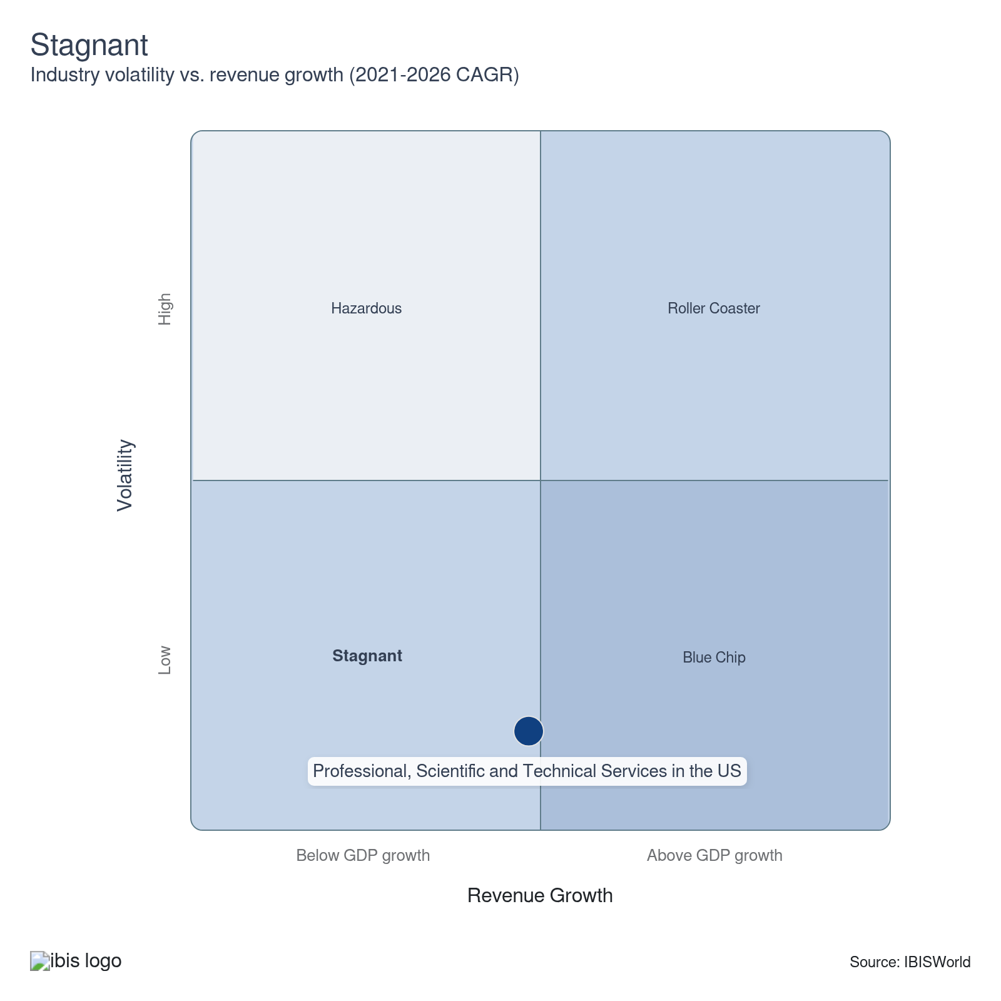

How do successful businesses overcome volatility?
Have a diverse range of clients
Having a diverse client base spreads risk across multiple industries and markets. Servicers that provide a variety of professional, scientific and technical services within different sectors reduce the impact of economic fluctuations on their core revenue niches.
Secure the latest and most efficient technologies and techniques
Servicers with the latest technologies in their workflow ensure companies use optimal processes and systems, boosting efficiency and productivity. Servicers in competitive areas can incorporate the latest technologies as a way of providing client services in a cost-effective manner.
Outlook | ↑ 2026-31 Revenue CAGR +1.9%

What's driving the industry outlook?

Businesses will continue to fuel the highest and most lucrative demand niches
- Strong corporate profit growth, which is anticipated to rise 6.0% over the next five years, will provide businesses and corporations with more capital to secure longer-term sector service commitments. The availability of more funding allows corporations to tackle discretionary issues that may have traditionally been done internally or via do-it-yourself (DIY) methods. For example, companies looking to refurbish their office may contract a specialist designer within the Interior Designers (54141) industry, which will generate niche demand for expert corporate designers across the professional services subsector.
- Businesses will introduce novel IT innovations to make office processes more efficient and safeguard proprietary information and client privacy, benefiting IT and management consultants specializing in corporate technology. According to a report from McKinsey and Company, client adoption of AI across one or more business functions inclined from 78% in 2024 to 88% in 2025. This was done in coordination with cloud computing and software development across their workflow. Incumbent service companies offering client-facing services, such as accounting and interior design, will look to diversify their service offering beyond one niche to capture a larger consumer market. Incorporating automation within their workflow can help reduce dependence on manual labor and maintain a competitive edge in saturated markets.
- Strong growth in total advertising expenditure, which is expected to grow 1.8% over the next five years, will bolster the performance of advertisers that continue to look to implement digital media and new advertising platforms to improve their services and attract downstream customers. Corporations looking to expand their digital footprint and strengthen their virtual position in communication and client awareness will look to hire qualified experts within the Public Relations firms (54182) industry as a way of expanding corporate visibility across digital markets.

Robust government spending will generate niche contracts for future service growth
- Federal policies, such as the Bipartisan Infrastructure Bill and the Inflation Reduction Act, will provide consistent growth to engineers, architects and scientific and economic consultants over the outlook period. The Bipartisan Infrastructure bill includes spending on transportation projects, high-speed internet, electric vehicle chargers, clean drinking water and green energy infrastructure, in addition to remediation projects benefiting demand for professional and technical services across the architectural, engineering and design subsectors. According to 2023 data from the Brookings Institute, $306.0 billion has already been invested at the state level for various infrastructure projects like road and bridge construction.
- The Inflation Reduction Act will bolster the performance of engineers, architects and scientific consultants as the act provides tax credits for designing energy-efficient buildings. Scientific and technical services will particularly benefit from a $400.0 billion investment into clean energy initiatives aimed at ensuring the United States becomes carbon-neutral by the end of 2030, according to data from McKinsey and Company. Industries such as Environmental Consulting (54162) will be in high demand among private companies looking to modernize their energy output via renewable sources adoption.
- However, despite positive trends in future government investment, research & development (R&D) will face uncertainty amid looming budget cuts. Engineers, architects and scientific and economic consultants derive a substantial portion of their business from federal entities. According to the American Association for the Advancement of Science (AAAS), the Department of Defense is set to receive a 4.9% budget boost. In contrast, the National Science Foundation is set to receive a 6.6% budget cut in R&D spending in the FY 2026 budget. This is critical, as federal agencies will be forced to pivot to in-house experts for professional and scientific service needs in fields such as consulting and R&D to complete public sector projects.
- While the cuts are damaging, incumbent service companies with public sector contracts are adapting by pivoting to state and local government contracts. For example, ICF International is bolstering consulting for statewide disaster recovery plans.

Uncertainty surrounding the future of interest rates will curtail robust long-term growth prospects
- While subsectors will continue to enjoy growth over the outlook period, downstream markets' attraction to sector services will slow down over the next five years, as interest rates remain elevated at 3.6% as of January 2026 per the Federal Reserve Board of Governors. Smaller, localized service providers, such as interior designers and lawyers, will struggle to adapt financially, as the higher costs of borrowing curtail their ability to expand service offerings and heighten key overhead costs like supply purchases and labor.
- Despite elevated interest rates, architects and engineers will benefit from the nonresidential construction market returning to growth, as this will provide construction clients with greater flexibility in pursuing professional and technical services that address building refurbishment and design. Anticipated 3.0% growth in nonresidential construction values will generate more profitable opportunities for interior designers and architects to craft unique building designs, as construction clients seek to maximize commercial building values for prospective buyers.
- Higher specialization services, such as lawyers and accountants, will continue to generate niche interest from larger clients and individual consumers looking for professionally vetted services to address complex issues like tax and family law. Nonetheless, industries that provide more individual-oriented consumer services, such as Photography services (54192), will face greater competition from in-house alternatives, as consumers embrace cost-efficient innovation by conducting photography services themselves.
- Greater competition proliferation will adversely affect smaller sector service providers, but larger providers will be relatively unharmed. Prominent companies such as Accenture Plc and Deloitte will be able to secure longer-lasting commitments from clients due to their brand name and reputation, two factors that will be integral in facilitating sector-wide growth across a larger customer base. Existing service providers are already planning ahead of competitive threats by offering expanded services that go beyond traditional client-facing tasks like tax preparation. For example, Ernst & Young is offering EY Helix to measure data pertaining to statement audits embedded within clients’ workflow.

Automation will become increasingly important and expand service efficiencies
- A core development over the next five years will be the expansion of automation and new technologies that will help maximize service efficiency. According to a report from Thomson Reuters, GenAI usage inclined from 12% of law firms in 2024 to 22% in 2025. Lawyers will enjoy saved time and fewer errors by implementing tools like ChatGPT, Gemini and Claude to produce documents, like contracts and agreements, conduct legal research and contract analysis, enabling them to focus on other value-added tasks. Incumbent law firms can adapt to future AI implementation by bolstering AI tool training, which can help bolster lawyer specialization and reduce dependence on manual labor for document-oriented tasks.
- Architects and engineers will continue implementing AI to improve their designs, run simulations of possible shortfalls in structures and enhance the efficiencies of various buildings, which will be especially important in designing energy-efficient buildings. The wider availability of AI services and faster technological tools available via software such as CAD will prove to be a core accelerant in service efficiency, as industries such as Architects (54131) look to lower overhead costs and expand revenue growth prospects. Incumbent architect companies like Ankrom Moisan are already responding to greater AI demand in the design space, implementing platforms like Midjourney to generate time-efficient 3D designs and accelerating workflow efficiency.
- Advertising companies will continue implementing programmatic ad buying through automated technology for media buying, which provides advertisers with a wide range of ad space inventory while at the same time reducing costs. Moving forward, the implementation of new technology like smart contracts will enable the self-execution of agreements between two parties, providing an efficient and cost-effective way to strengthen servicers’ internal workflows and securely store consumer data in a decentralized manner.
Life Cycle | Mature

Why is the industry mature?

Contribution to GDP
Professional, scientific, and technical servicers are growing at a faster pace compared with the domestic economy. Strong consumer spending and overall business activity has driven growth across client-facing industries like accounting and interior design. Higher corporate profit boosted outsourcing of legal and technically intensive services, strengthening sector contributions to US GDP.

Market Saturation
There is limited market saturation due to a high quantity of services and a diverse array of clients. The sector hosts many small businesses, varying by subsector in saturation levels, with consultants a frequent leader of overall market share. However, there is no single service dominating the sector, as establishments are exposed to a range of client needs.

Innovation
Technological innovation has been integral in shaping professional service efficiency and quality. Digital media has reshaped service offerings in advertising and public relations operations. Architects and engineers now integrate AI and computer-aided design, strengthening their workflow efficiency and boosting client satisfaction.

Consolidation
Consolidation is extremely limited, with strategic acquisitions on the rise among large companies aiming to enhance technology capabilities. International law firms are broadening their global reach to better serve multinational clients. While major companies like Accenture Plc and the Big 4 are meaningful operators, the scope of service proliferation and robust nonemploying market limits large-scale consolidation.

Technology & Systems
System advancement has been key in modernizing professional service offerings. Cloud computing drives the digitization of workspaces and media consumption. Automation is increasingly prevalent in legal, advertising, architectural and engineering services, boosting efficiency and productivity. New technologies, such as blockchain, have helped service providers modernize their data and information security.

4. Products and Markets
https://my.ibisworld.com/us/en/industry/54/products-and-markets

Key Takeaways
- Corporate profit growth is driving increased demand among business clients. Rising national GDP and higher corporate profit generates greater business interest in professional and technical services.
- Macroeconomic growth benefited the professional and technical services sector overall. However, some subsectors, such as architectural and engineering services, contracted amid elevated interest rates and an uneven housing market.

Products and Services
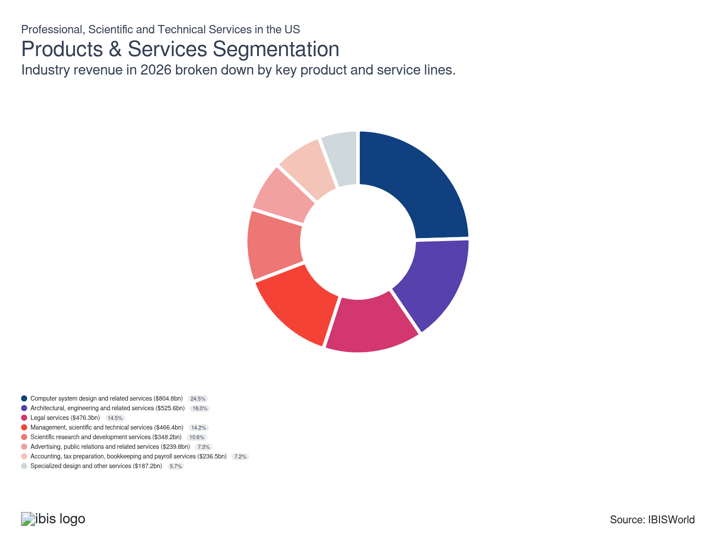

How are the industry’s products and services performing?

Computer systems design and related service providers grew as IT infrastructure expanded
- The computer system design and related services segment comprises companies that provide custom software, integrated hardware, communications infrastructure and on-site management of computer systems and data processing facilities.
- The proliferation and complexity of IT infrastructure for businesses bolstered the need for computer systems design. The trend toward outsourcing many IT solutions also benefited this subsector, with digitalization of professional services across client-facing industries such as the Payroll & Bookkeeping (54121b) industry and continued emphasis on digital solutions for client needs driving segment demand.
- Brand name companies such as Accenture Plc make up the bulk of segment demand, offering niche services such as cloud computing and digital engineering. The overall segment slipped over the past five years amid heightened competition from software providers. Nonetheless, consulting and technical industries like Management Consulting (54161), continue to drive lucrative revenue streams.

Interest rate fluctuations induced volatility for architectural, engineering and related services providers
- The architectural, engineering and related services segment provides services which include preparing feasibility studies, project management services and architectural design. Designers and architectural clients drive most segment demand due to reliance on quality design layouts, making it the second-largest sector revenue driver.
- Because the prevalence of architectural and design services is so high, there is considerable collaboration done with construction companies. Prominent design firms like Gensler from the Industrial Designers industry (54141) procure feasibility studies to ensure a potential design project can proceed successfully.
- A 0.4% slip in housing starts over the past five years curtailed architect and engineer demand across construction facilities. Elevated interest rates caused construction companies to prioritize greater in-house usage of engineering-oriented services. Nonetheless, a critical 3.1% boost in nonresidential construction valuations provided a secondary revenue stream within commercial market construction.

Consistent downstream demand for quality consultations boosts management, scientific and technical consulting services segment
- The management, scientific and technical consulting segment assists businesses, nonprofit organizations and public-sector agencies in organizational design, human resources, corporate strategy, information technology strategy, marketing and sales, finances and logistics.
- Consultants and consultant-based work is highly dependent on stable economic conditions, particularly as the core client base is comprised of private businesses. Growing corporate profit incentivizes companies to procure consultant services, whether it be to address present-day challenges or provide projections on future trends. For example, Uber hired Deloitte as part of its consulting branch to guide the company through the inflationary wave in 2022.
- The Managerial Consulting (54161) industry is one of the highest demand drivers within the segment. Consulting companies, such as Deloitte, offer a range of consulting services that address topics such as trending technologies and developments in the labor market.
- The implementation of new tariffs in 2025 pushed higher demand for strategy-focused services. Major companies like KPMG reacted by unveiling proprietary tools like KPMG Tariff Modeler, providing greater transparency on evolving trade conditions and client support on how to adapt their corporate strategies.

A diverse array of representation needs bolsters the legal services segment
- The legal services segment provides expertise in a variety of law-related topics, such as criminal, corporate, family and estate law, patent, real estate or tax laws. Companies and individual customers alike are popular drivers of segment demand, as both require legal services to address their legal issues.
- The unique appeal of legal services is the wide range of markets and topics it applies to. Most segment demand is driven from professional service clients who use lawyers to resolve disagreements or contract issues.
- Economic volatility drove demand for law professionals specializing in estates, healthcare and employment. According to Thomson Reuters, non-equity lawyers made up 19.1% of the overall legal landscape in 2024, highlighting the pivot toward consumer-oriented legal issues. Legal services for litigation, intellectual property and mergers and acquisitions spurred growth for the subsector in recent years.

Expanding federal funding benefited scientific research and development services
- The scientific research and development services segment includes agricultural, biotechnology, cancer, computer and related hardware research and development. Clients frequently procure these services when looking to expand knowledge about a developing technology or health trend.
- Higher rates of defense spending are some of the biggest drivers of this segment’s demand. The ongoing Russia-Ukraine conflict and instability in the Middle East continued to bolster defense spending. Federal R&D funding also provided greater opportunities for scientific R&D specialists. In the FY 2026 budget proposal, R&D funding for the Department of Defense inclined from $96.1 billion in FY 2025 to $100.8 billion in FY 2026, according to the American Association for the Advancement of Sciences (AAAS).
- The proliferation of novel technologies like nanotechnology, medical diagnostic imaging and materials research will spur growth for this subsector. Companies within the Scientific & Research and Development (54171) industry continue to boost demand, as new innovations facilitate a need to test and validate their market viability.

Accounting, tax preparation, bookkeeping and payroll service providers enjoyed steady growth amid significant policy changes
- The accounting, tax preparation, bookkeeping and payroll services segment provides a wide range of accounting services, including auditing accounting records, designing accounting systems, preparing financial statements and regulatory filings and developing budgets.
- The increasing complexity of the tax code continues to attract customers to this subsector as companies outsource these services. The passage of the One Big Beautiful Bill Act (OBBBA) in July 2025 prompting higher client interest in professional accountants and bookkeepers to navigate the policy changes. Larger accounting service providers, such as Intuit and H&R Block, have expanded their digital payroll services portfolio in an attempt to maximize efficiency and boost customer service.
- Steady 0.7% growth in disposable income over the past five years provided clients with greater availability to procure professional accounting services. The push to digitize tax preparation also benefited well-established accounting companies, although it also bolstered external digital competitors.

Advertising and PR services endure mixed results amid strong digital marketing demand and in-house competition
- The advertising, public relations and related services segment comprises companies engaged in running marketing campaigns, managing public relations (PR) and ensuring clients remain on top of the latest media trends.
- An evolving media landscape led billboard and outdoor advertisers, direct mail advertisers and print advertising distributors to suffer. According to Pew Research, 94.0% of all consumers used the internet to stream or watch news in 2025. This generated higher interest for advertising agencies, public relations companies and media buying agencies, which have been able to leverage digital media to facilitate higher engagement and product advertisement across a basket of clients.
- While expanding digital media benefited and media buying agencies and digital advertisers, public relations firms are struggling as consumers shifted to in-house substitutes to preserve capital. In contrast, marketing consultants are performing well as consumers seek help navigating new digital channels and maximizing marketing campaign outreach.

Technological advancements bolster service efficiency across specialized design and other service providers
- The specialized design and other services segment include market researchers, photographers, translators, veterinarians, credit counselors, surveyors and appraisers that work with clients to address design and financial needs.
- Veterinarians benefited from technological advancements, such as AI and digital imaging technology, enabling them to provide more expensive services like advanced surgeries. Surging pet ownership strengthened local veterinarian demand, boosting segment growth in the past five years. According to the American Pet Products Association (APPA), pet ownership inclined from 82 million households in 2023 to 94 million households in 2024.
- Higher emphasis on specialized services boosted demand in this subsector, with more downstream customers prioritizing quality service. Expansion of digitalization within these spheres enhanced companies’ efficiency, with areas like market research gaining access to more data they can track in real-time and enjoy reduced costs by gathering data online.

What are innovations in industry products and services?

Automated systems are expanding legal and digital media landscapes
- The adoption of digital media and automated systems have been integral in shaping how sector-wide industries provide client service and expand their visibility in competitive markets. Adoption of artificial intelligence (AI) has been a key driver in facilitating quality services via automated processing of client data, detailed breakdowns of a design layout and reducing dependence on manual labor.
- Law firms use AI for tasks like document production, analysis and management consulting, generating improved client satisfaction and more efficient internal workflows. American law firms, such as Latham & Watkins, invested more capital into AI-oriented roles to accelerate automation efforts within their workflow, per Law.com.
- Tech advancements, especially in digital media, have revolutionized advertising. Many advertising agencies currently use tracking technology to understand consumer behavior for optimal ad placement and deploy cost-effective viral marketing strategies to maximize consumer outreach.

Computer-aided design increases architects' and engineers' capabilities
- Specialized servicers that engage within the architectural and construction sectors across the United States use computer-aided design (CAD) technology as a way of maximizing workflow efficiency via digital expansion and completion of various engineering tasks without requiring manual labor input.
- Computer-aided design (CAD) technology empowers architects and engineers to create intricate 3D models efficiently, with many servicers incorporating this technology to provide improved product designs. Prominent architectural companies like Gensler are heavy users of CAD technology, enabling them to deliver quality designs without relying heavily on manual input.
- CAD software streamlines the design process, reducing errors and enhancing overall productivity, while also improving both functionality and aesthetics within designers and engineers’ workflow. Smaller design and engineering firms will look to adapt the technology to ensure their services remain ahead of vertical competitors.

The adoption of blockchain technology offers unique data and records storage method
- Although a relatively new and novel technology, blockchain is making waves across the sector due to how efficiently it stores data and provides clients with a streamlined way to maintain digital records. The unique aspect of blockchain is its decentralized nature, allowing servicers with heavy storage of sensitive data to maintain direct data oversight.
- Companies with large quantities of physical goods, such as waste collection services, can oversee their stock more efficiently and conduct transactions with end clients in a safer and faster process. As servicers shift toward control of transaction oversight and more secure data storage, blockchain offers greater transparency in facilitating service coordination.
- The decentralized aspect of smart contracts, coupled with adoption to the latest compliance and regulatory standards, provide an efficient and cost-effective way in strengthening servicers’ internal workflows.

What products or services do successful businesses offer?
Identify and assess demographic and social trends
Servicers that effectively assess the latest societal trends can tailor their solutions to meet evolving client demands, enhancing relevance and appeal to broad or niche markets.
Develop sophisticated computer technologies
Servicers that adopt the latest cutting-edge technology solutions enhance service efficiency and effectiveness. By developing their own computer technologies, servicers can generate proprietary solutions and improve workflow efficiency.

Major Markets
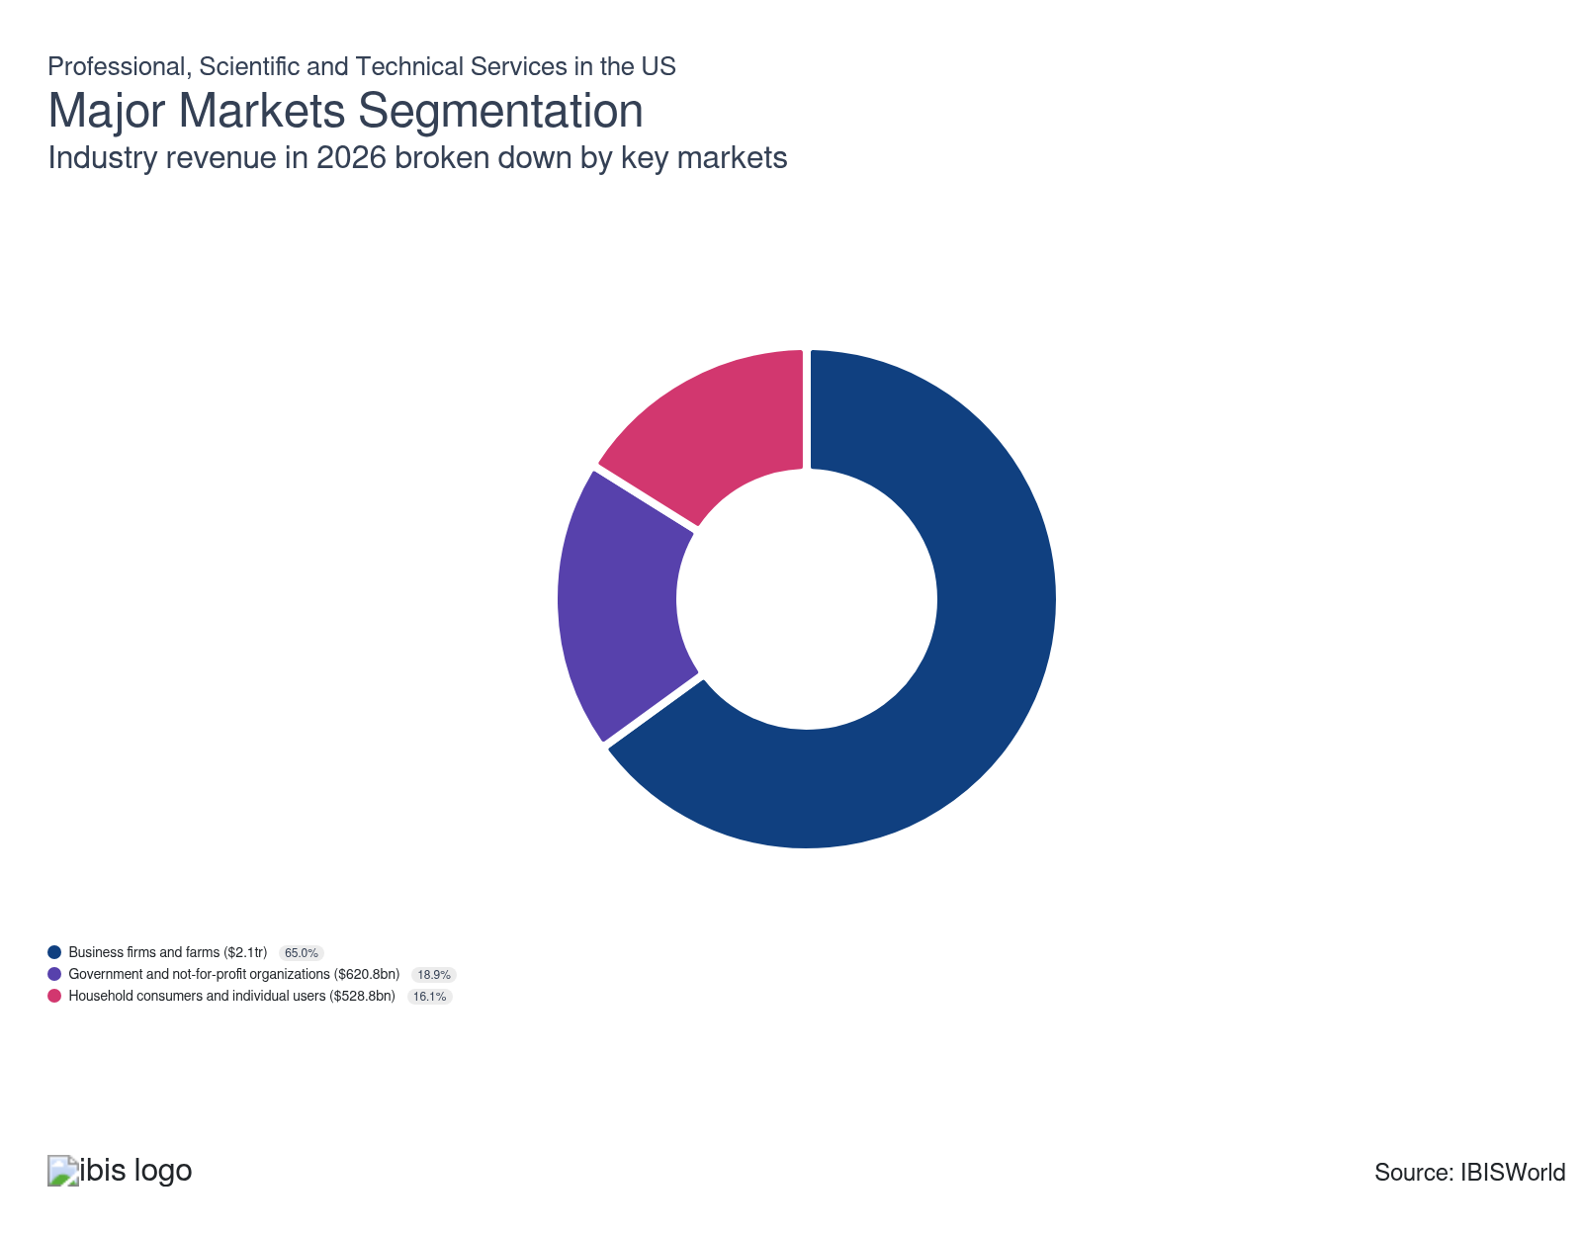

What’s influencing demand from the industry’s markets?

Economic instability expands in-house competitive threats across businesses, firms and farms segment
- The businesses, firms and farms segment make up the largest and most consistent share of revenue for sector-wide industries. Businesses require a broad range of services from companies in this sector, including advertising, accounting, legal services, public relations, research and development and translation.
- The sector is heavily reliant on strong business sentiment and corporate profit growth, as these factors provide businesses with the necessary resources to procure professional and technical services. Some businesses, such as those in the financial or medical sciences space, procure professional and scientific research services specializing in areas like financial consulting and R&D projects.
- A robust 6.1% boost in corporate profit in the past five years provided greater leverage for business clients to procure external professional services. Aggressive interest rate policy implemented by the Federal Reserve during 2022-2023 harmed consumption levels and heightened corporate expenses, accelerating in-house However, stabilization in employer compensation costs helped curtail a large-scale pivot to in-house alternatives. According to the BLS, wages as a share of employer compensation costs marginally changed, from 69.2% of expenditures in 2024 to 69.3% in 2025.

A turbulent economic environment induced volatility from household consumers and individuals
- The household consumers and individual users market makes up the smallest revenue stream for the sector, with niche demand stemming from users contracting professional and technical services from lawyers, accountants and designers.
- Individual consumers are less likely to procure sector services, as in many cases they look to resolve their issues via do-it-yourself (DIY) methods. For example, if a household is looking to undergo a design renovation within their home, they may look to do it themselves if the sector-aligned service is too expensive.
- Despite rising per capita disposable income, which rose 0.7% over the past five years, economic uncertainty amid an evolving tariff landscape and elevated interest rates reduced individuals' propensity to pay for services. Although consumers had greater fiscal flexibility to procure a professional service to meet their needs, a hawkish interest rate environment is harming lower-income clients’ ability to procure professional services.
- While uneven demand persists based on consumers’ disposable income levels, demand for legal advice and financial guidance generated interest across professional services such as Law Firms (54111) and Accounting Services (54121c).

Government and not-for-profit organizations reduced spending on services
- The government and not-for-profit organizations segment is made up of state, local and federal government agencies and nonprofit organizations. These clients primarily contract professional and scientific services, particularly in the spheres of legal representation, research and development (R&D) and consulting.
- Federal government spending was a boon to this market in the past few years. Robust spending programs, such as the CHIPS and Science Act, Bipartisan Infrastructure Law and Inflation Reduction Act generated niche demand for aligned services such as R&D and scientific consulting to enable efficient appropriation of the funds.
- Higher interest rates, which peaked at 5.3% in July 2023, curtailed public sector clients’ ability to procure long-term professional services. The federal government responded by prioritizing in-house servicing of advisory and consulting-related tasks, according to a May 2025 executive order from the Department of Defense.

International Trade

Some industries don't directly import or export goods. See reports at the manufacturing level for international trade data on relevant products.

5. Geographic Breakdown
https://my.ibisworld.com/us/en/industry/54/geographic-breakdown

Key Takeaways
- The Southeast is a major hub for the legal and accounting industries. Dense business concentration and a robust population are core factors that attract a variety of professional lawyers and accountants.
- Robust technological presence generates significant servicer demand. Silicon Valley, large cities and media production companies are crucial demand facilitators for technical servicers in states such as California.

Business Locations
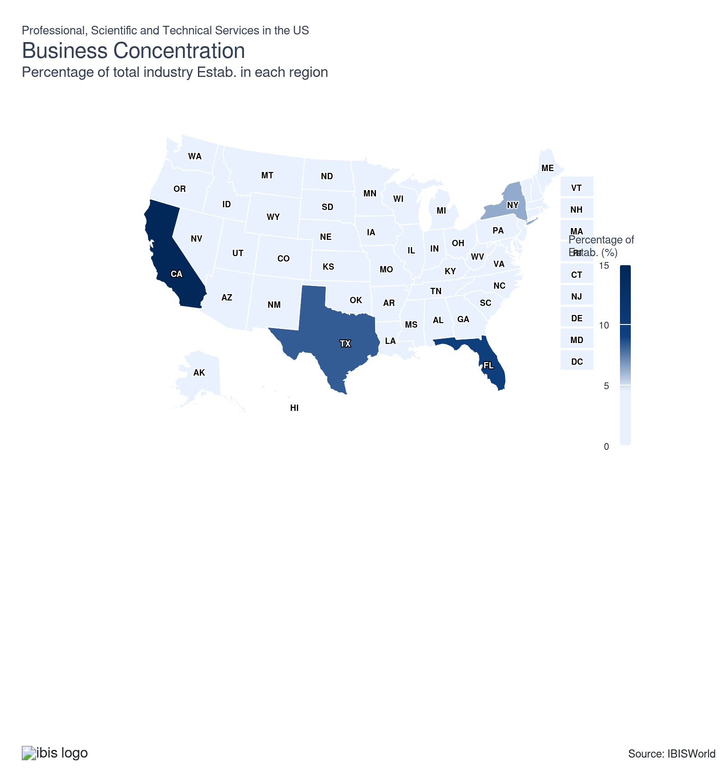
State | Estab.  Units | Estab.  % | Population  %
California | 142540 | 2.7 | 11.5
Florida | 92313 | 1.7 | 7.0
Texas | 81011 | 1.5 | 9.4
New York | 61831 | 1.2 | 5.8
Illinois | 38012 | 0.7 | 3.7
Georgia | 32446 | 0.6 | 3.3
Virginia | 31844 | 0.6 | 2.6
Pennsylvania | 30244 | 0.6 | 3.8
New Jersey | 28935 | 0.5 | 2.8
Colorado | 28086 | 0.5 | 1.8
North Carolina | 27428 | 0.5 | 3.3
Ohio | 23623 | 0.4 | 3.5
Washington | 23454 | 0.4 | 2.3
Massachusetts | 21931 | 0.4 | 2.1
Michigan | 22097 | 0.4 | 3.0
Maryland | 21432 | 0.4 | 1.8
Arizona | 20330 | 0.4 | 2.2
Minnesota | 16161 | 0.3 | 1.7
Indiana | 13212 | 0.2 | 2.0
Missouri | 13768 | 0.3 | 1.8
Oregon | 13188 | 0.2 | 1.2
Utah | 13166 | 0.2 | 1.0
Louisiana | 12400 | 0.2 | 1.3
South Carolina | 12226 | 0.2 | 1.6
Tennessee | 12334 | 0.2 | 2.1
Wisconsin | 11562 | 0.2 | 1.7
Nevada | 10537 | 0.2 | 1.0
Oklahoma | 9944 | 0.2 | 1.2
Connecticut | 9102 | 0.2 | 1.1
Kentucky | 8270 | 0.2 | 1.3
Alabama | 9682 | 0.2 | 1.5
Iowa | 6461 | 0.1 | 0.9
Kansas | 7136 | 0.1 | 0.9
Arkansas | 6177 | 0.1 | 0.9
District of Columbia | 5703 | 0.1 | 0.2
Idaho | 5724 | 0.1 | 0.6
Mississippi | 4620 | 0.1 | 0.9
Nebraska | 4738 | 0.1 | 0.6
New Mexico | 4589 | 0.1 | 0.6
Delaware | 4094 | 0.1 | 0.3
Hawaii | 3417 | 0.1 | 0.4
Maine | 3662 | 0.1 | 0.4
Montana | 4233 | 0.1 | 0.3
New Hampshire | 3752 | 0.1 | 0.4
Rhode Island | 3077 | 0.1 | 0.3
West Virginia | 2637 | 0.0 | 0.5
Wyoming | 3068 | 0.1 | 0.2
Alaska | 1973 | 0.0 | 0.2
North Dakota | 1887 | 0.0 | 0.2
South Dakota | 2165 | 0.0 | 0.3
Vermont | 2081 | 0.0 | 0.2

Where are industry businesses located?

Robust population enhances professional services demand in the Southeast
- The Southeast's large population attracts a variety of professional and scientific service providers to the region. Many law firms establish themselves to meet the needs of individuals and businesses, offering legal expertise and support where it's most in demand.
- A lot of professional and scientific services have found a steady demand niche across the Southeast, as the region’s tax-friendly climate has facilitated higher demand for legal services and research & development (R&D) initiatives. According to 2025 data from the American Bar Association, North Carolina had one of the highest spikes in new lawyer volumes, growing 15.0% over the past decade.
- Florida's robust state economy also fuels demand for accountants, bookkeepers and payroll service providers, with a growing business density and corporate presence in the state accelerating demand for accurate business and financial records. Major accounting companies, such as KPMG and PwC, maintain robust regional presence in cities like Miami and Jacksonville, which drives higher sector visibility in the area.

Steady technical presence enhances servicer demand in the West
- The Western region drives considerable demand for the sector due to the presence of robust local population and a booming tech space. Silicon Valley's start-up culture drives the concentration of specialized design companies in the Western region, with California serving as a hot environment for technical service sectors.
- Corporate advertisers and media production companies are prevalent in states such as California, benefiting from the state's robust media and entertainment industry. The release of new films and documentaries makes Hollywood a popular destination for industries such as the Public Relations Firms (54182) industry, as clients look to ensure accurate and widespread exposure across target audiences.
- Although the West remains a hotspot for expensive professional services, such as lawyer services and accounting, the region struggled to maintain broader demand amid slower housing construction. According to the US Census, California slipped to 34th in new housing units authorized in 2025 from 28th in national rankings in 2024. The state continues to grapple with difficulty meeting the housing shortfall, reducing interest in new interior designers and personalized service niches across the region.

New York City magnifies the number of businesses in the Mid-Atlantic
- The professional, scientific and technical services sector benefits heavily from the wide array of corporate and individual clients available in the Mid-Atlantic. The region houses servicers from a variety of industries, with consulting firms and designer companies routinely generating demand via provision of tax consulting and residential design services, respectively.
- Many advertising agencies and public relations firms gravitate towards New York City to remain close to the headquarters of large corporations. The Big 4 accounting companies are all headquartered in New York City, providing a regional and visibility boost to professional accounting services. In 2025, Deloitte announced the expansion of its New York headquarters by moving to 70 Hudson Yards and securing a larger regional presence in the area. Efficient coordination and client communication ensure quality professional service execution and boosts relations between clients and servicers.
- New York City’s finance industry attracts a high concentration of computer systems design companies. Globally recognizable companies, such as DataArt and Accenture, house their headquarters in the state. Servicers’ proximity to the financial and technical sectors provides a consistent client base and lucrative collaboration opportunities, as companies such as Accenture Plc and Deloitte provide a diverse array of consulting and financial services.
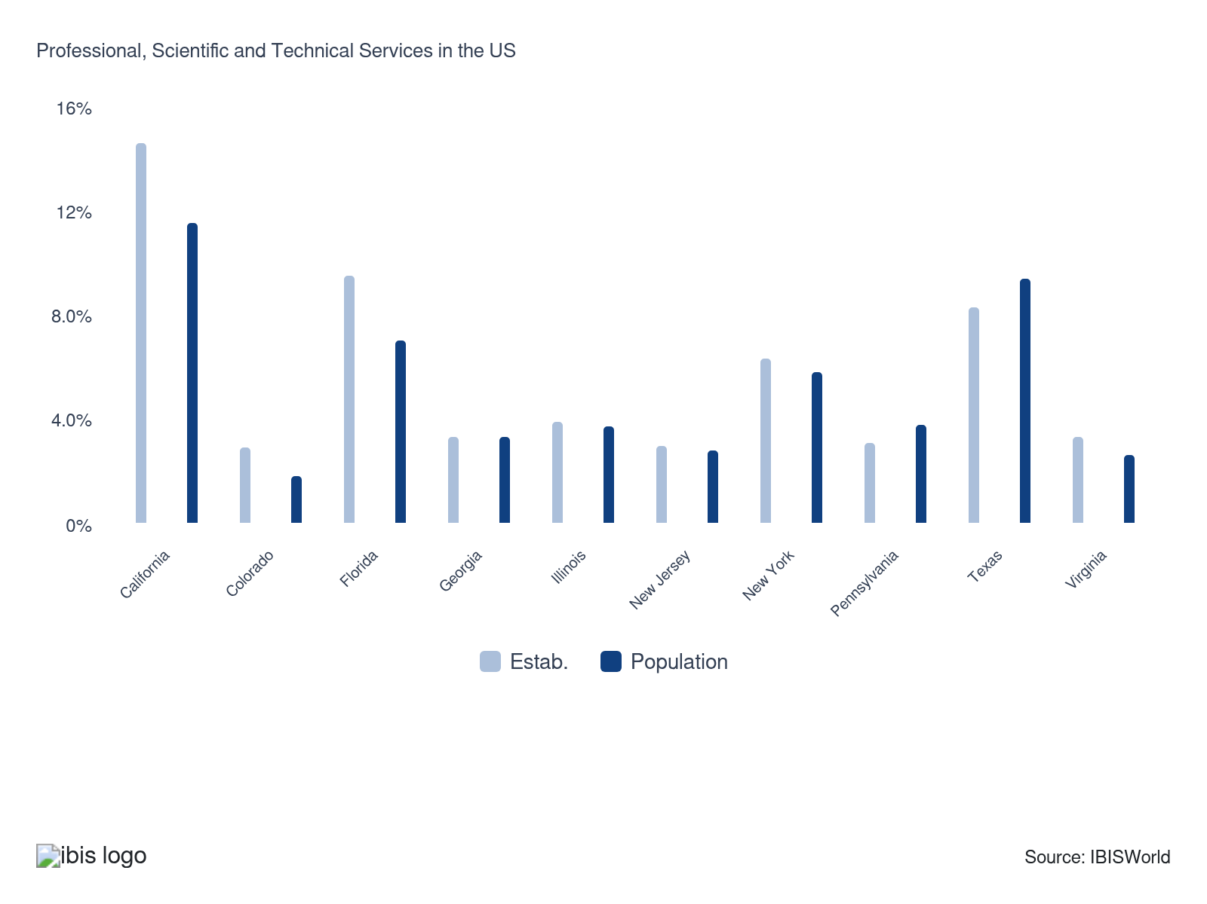

How do businesses use location to their advantage?
Attract local support
Companies in the professional, scientific and technical services sector with local support can generate repeat clients more efficiently via word-of-mouth recommendations. Strong local support bolsters customer trust and strengthens a servicer’s localized branding.
Ensure skilled labor is available
Servicers are in constant need of employees that are qualified, knowledgeable and possess expertise in their respective fields. Setting up offices in areas with large education hubs strengthens proximity to skilled employees and boosts service standards.

6. Competitive Forces
https://my.ibisworld.com/us/en/industry/54/competitive-forces

Key Takeaways
- The sector is highly competitive. Servicers primarily compete on cost, quality of service and adoption of the latest technological innovations, enabling more efficient customer growth in a fast-paced market.
- The sector faces minimal external competition. Most competition occurs at the internal level, as sector-oriented industries compete against each other.

Concentration
Low

What impacts the industry’s market share concentration?

The overall size of the sector keeps concentration low
- Because the professional, scientific and technical services space is so robust and generates considerable revenue across multiple markets, there is no opportunity for any company to secure a large enough market share across the entire sector.
- The sheer number of industries within the sector prevents any single company from gaining a significant market share, as clients from a variety of specialized niches demand professional, scientific and technical services.
- Even large companies with thousands of employees and a wide array of services can’t manage to capture more than 1.0% of the sector’s market. The high saturation of competition also prevents any one company from dominating the market, with close to 80% of all establishments functioning as nonemployers.

Diversified service offering and competition contribute to low sector-wide concentration
- The sector offers a diverse range of services, with certain specialties generating higher revenue. This revenue disparity affects market share concentration, with servicer specialization influencing client demand. Downstream clients are more likely to look for proven companies with a track record of successful service offering.
- Large consulting firms hold the largest market shares within the overall sector. However, their earnings are minimal compared to overall sector revenue. Across other service niches, no other major company secures greater than 1.0% market share, as the robust presence of nonemployers creates a saturated landscape with numerous price-friendly alternatives for clients.
- Nonetheless, brand name companies, such as Intuit and Accenture Plc, are highly influential within the accounting and management consulting spaces, respectively. Larger clients will be likelier to pursue services from those companies, as they prioritize efficiency and name recognition.

Low barriers to entry offer swathe of opportunities for new entrants
- Since the sector exhibits limited barriers to entry, it provides a variety of opportunities across in-demand service niches, such as accounting and design services. New entrants have greater opportunities to secure a steady revenue stream, as they can prioritize specialization in a specific service segment that clients seek out.
- With 80.5% of establishments operating as nonemployers, there is a wide range of local servicers that can appeal to businesses and individual clients alike. Most of these servicers are concentrated within the professional services space, as industries such as the Interior Design (54141) space exhibit high rates of competition amid a lack of diversified service offerings.
- While high regulatory oversight does discourage new entrants within competitive spaces such as scientific services, there is no significant roadblock for local services to set up shop and procure a consistent client niche.

How do successful businesses handle concentration?
Having a good reputation
Companies with a strong reputation benefit from repeat clients and can generate word-of-mouth recommendations more effectively. Clients are more likely to procure more reputable services, generating greater company stability in competitive markets.
Access to highly skilled workforce
Professional, scientific and technical servicers with qualified, knowledgeable employees generate greater client trust. If a servicer has a strong employee pool with specialization in their service niche, they can undermine demand toward their closest competitors.

Barriers to Entry
Low | Steady

What challenges do potential industry entrants face?

Legal
- There are considerable legal barriers for many professional, scientific and technical servicers that are primarily derived from federal and state regulatory oversight. Licensing and certification requirements are key challenges for lawyers, accountants and veterinarians. Compliance with copyright legislation and intellectual property laws is also essential for technical servicers, such as the Industrial Designers (54141) industry.

Start-up Costs
- Most servicers face limited capital barriers because they typically don't require heavy machinery or industrial facilities, minimizing the impact of initial expenditures. Many of the start-up costs focus on equipment procurement and supplies, such as computers, desks and office space.

Differentiation
- There is considerable differentiation across the sector, since servicers serve a variety of client niches. The largest rate of differentiation is across the professional services sector, with industries such as Accounting Services (54121c) able to offer a wide variety of tax-related and consulting services. Establishing long-term relationships with clients is difficult for new entrants, with existing client relationships predicated on trust and quality service.

Labor Expenses
- The overall sector relies heavily on qualified and specialized employees to provide excellent client service. New entrants, especially those hiring engineers or veterinarians, must offer high salaries to attract highly skilled and well-educated workers. Technically intensive industries, such as Stock & Commodity Exchanges (52321) rely heavily on technically adept workers that can handle large client volumes and resolve client queries efficiently.

How can potential entrants overcome barriers to entry?
Ability to quickly adopt new technology
Adopting the latest technologies enhances servicers' processes and systems, boosting their efficiency and productivity. Servicers with quick technological adoption enhance their reputation, as clients will trust them to deliver services in a timely and quality manner.
Must have license
A license is mandatory for several industries, including veterinary services and accountants, who must be certified as CPAs. Servicers that adhere to the latest licensing standards ensure they can provide quality, trustworthy services to a variety of clients.

Substitutes
Low | Steady

What are substitutes for industry services?

Other industries in the sector
- While some substitutes exist for industries within the Professional, Scientific, and Technical services sector, the common alternatives often stem from within the sector itself due to the need for a high degree of expertise.
- Advertising agencies are increasingly replacing marketing consultants and public relations firms, as consumers seek one-stop shops for their advertising needs at a more affordable cost. Some services traditionally provided by lawyers, such as crafting employee contracts and benefits counseling, are now being handled by accountants or human resource companies in an attempt to provide cost-effective, specialized services.
- Although some consumer-facing industries may have do-it-yourself (DIY) alternatives, they are limited to smaller industries with little service specialization. Services such as accounting and R&D can only be completed by professionals with expertise in the field.

How do successful businesses compete with substitutes?
Close monitoring of competition
Most companies in this sector face intense competition. Staying updated on competitors' latest services ensures servicers stay up-to-date on client expectation, enabling more efficient services that can undermine direct competition.
Invest in research and development
R&D investment ensures Professional, scientific and technical services stay ahead of the latest industry-wide trends. Continual innovation helps firms offer cutting-edge solutions, making it harder for substitutes to compete on quality and technological advantages.

Buyer & Supplier Power
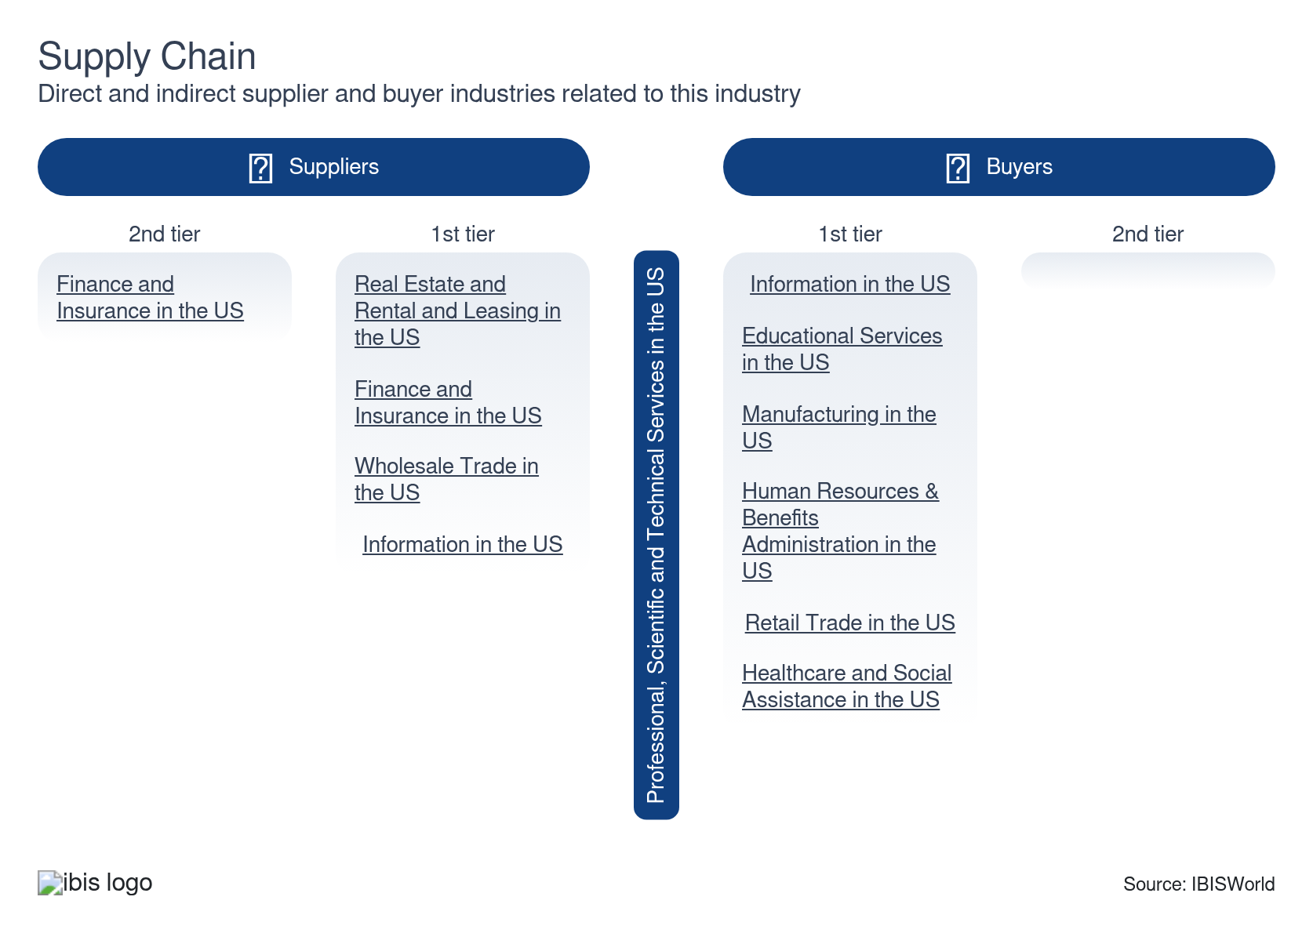

What power do buyers and suppliers have over the industry?

Buyers: Low switching costs
Moderate | Steady
- Buyers hold considerable power through bidding processes common in the sector. They have significant input on cost, schedules and payment terms once bidding concludes. If a buyer is not satisfied with the terms offered by a servicer, particularly those in the professional services space, they can easily switch between vertical providers or pursue substitute services altogether.
- Buyers are very influential within the professional services sphere; for example, when selecting a lawyer, buyers can compare prices, competency, business knowledge, reputation and image. They can evaluate companies offering accounting, tax preparation, books and payroll services based on governance, risk management, and service quality.
- Assessment of the ingenuity, effectiveness and practicality of services provided by architects, engineers and related professionals influences buyer decisions, with flexibility available if buyers want to switch to a different servicer.

Suppliers: Advertising platforms and software developers
Moderate | Increasing
- Suppliers have grown in influence across the sector due to their ability to negotiate higher prices on niche services such as software provision and equipment sales to downstream clients. As more professional and scientific industries embrace digitalization, they require greater input from digital tools and software to facilitate quality client service.
- Suppliers like advertising platforms and software developers hold significant power through their stringent standards and regulations. These heightened regulations force advertisers to ensure their content respects the latest regulatory framework, often incurring additional costs and operational adjustments.
- Although some suppliers have considerable influence across technical services, larger companies within the sector that are client-facing, such as Accenture Plc, can leverage economies of scale to secure more favorable supplier contracts for these tools and offset large-scale effects on overhead expenses.

How do successful businesses manage buyer & supplier power?
Ability to effectively communicate and negotiate
Effective and transparent communication helps companies meet client expectations. Strong client communication and efficient negotiations enable servicers to meet buyers’ interests more effectively.
Develop a loyal customer base
Building a loyal customer base is crucial, as repeat clients and their word-of-mouth recommendations bolster servicers’ standing. Developing strong customer loyalty leads to sustained business growth and discourages clients from seeking out service alternatives.

7. Companies
https://my.ibisworld.com/us/en/industry/54/companies

No single company accounts for more than 5% of total industry market share.

8. External Environment
https://my.ibisworld.com/us/en/industry/54/external-environment

Key Takeaways
- Most sector support is derived from private associations. Some subsectors also benefit indirectly from government contracts, which generate indirect public assistance for niche servicers.
- Most subsectors must follow industry-specific regulations. In some fields, such as accounting, special certifications are required, while other fields follow federal regulations from agencies such as the Federal Trade Commission (FTC) to ensure legal and ethical service provision.

External Drivers

What demographic and macroeconomic factors impact the industry?
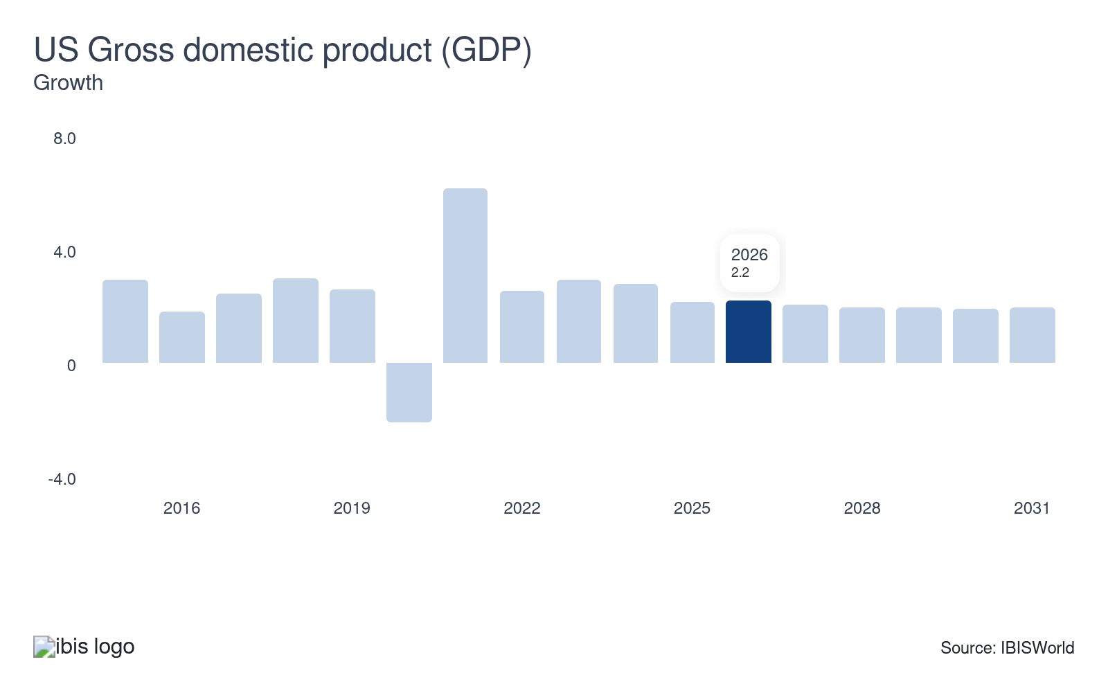
The performance of the US economy influences demand for a range of services provided by the sector. For example, during periods of stable GDP growth, businesses become more inclined to increase spending on advertising, consulting, research and development activities. Conversely, slumping GDP indicates significant macroeconomic weakness and may force clients to look for less expensive alternatives to professional services.
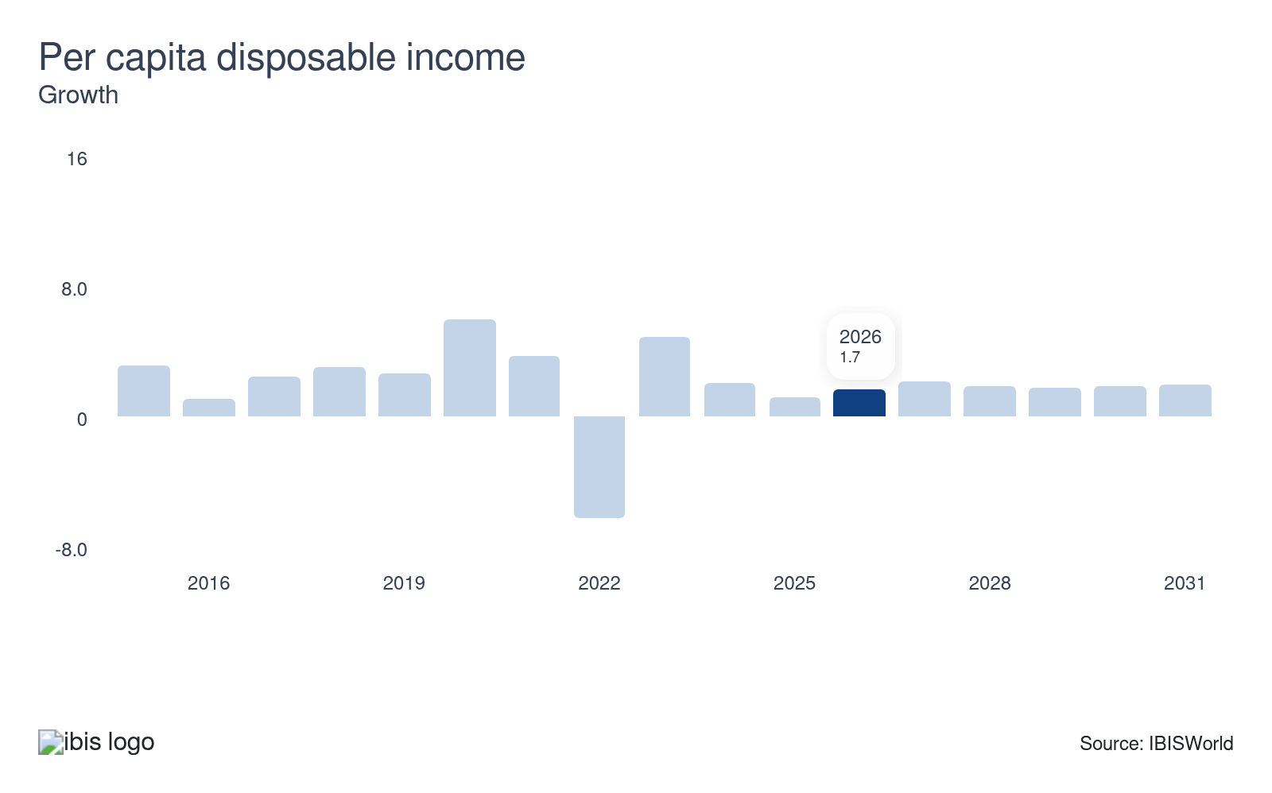
Per capita disposable income affects demand for sector services from US households and consumers. Examples include veterinary, photography, legal and accounting services and drafting services. Higher disposable income tends to increase consumer spending and bolsters businesses' demand by increasing their revenue. During times of economic hardship, disposable income tends to slump, as consumers look to preserve capital toward more mandatory expenses.
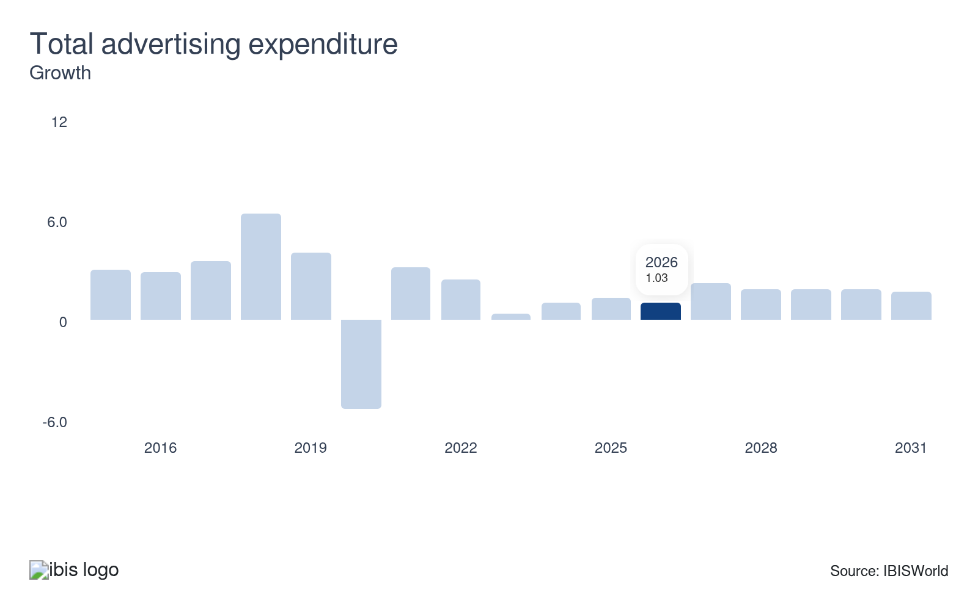
Total advertising expenditure indicates spending on advertising, promotional and marketing activities. This sector is directly affected by media and promotional expenditures by corporate and government clients. Growth in total US advertising expenditure positively affects sector revenue, as it allows for professional services to generate greater marketing and bolsters visibility regarding their services, representing a potential opportunity for servicers.
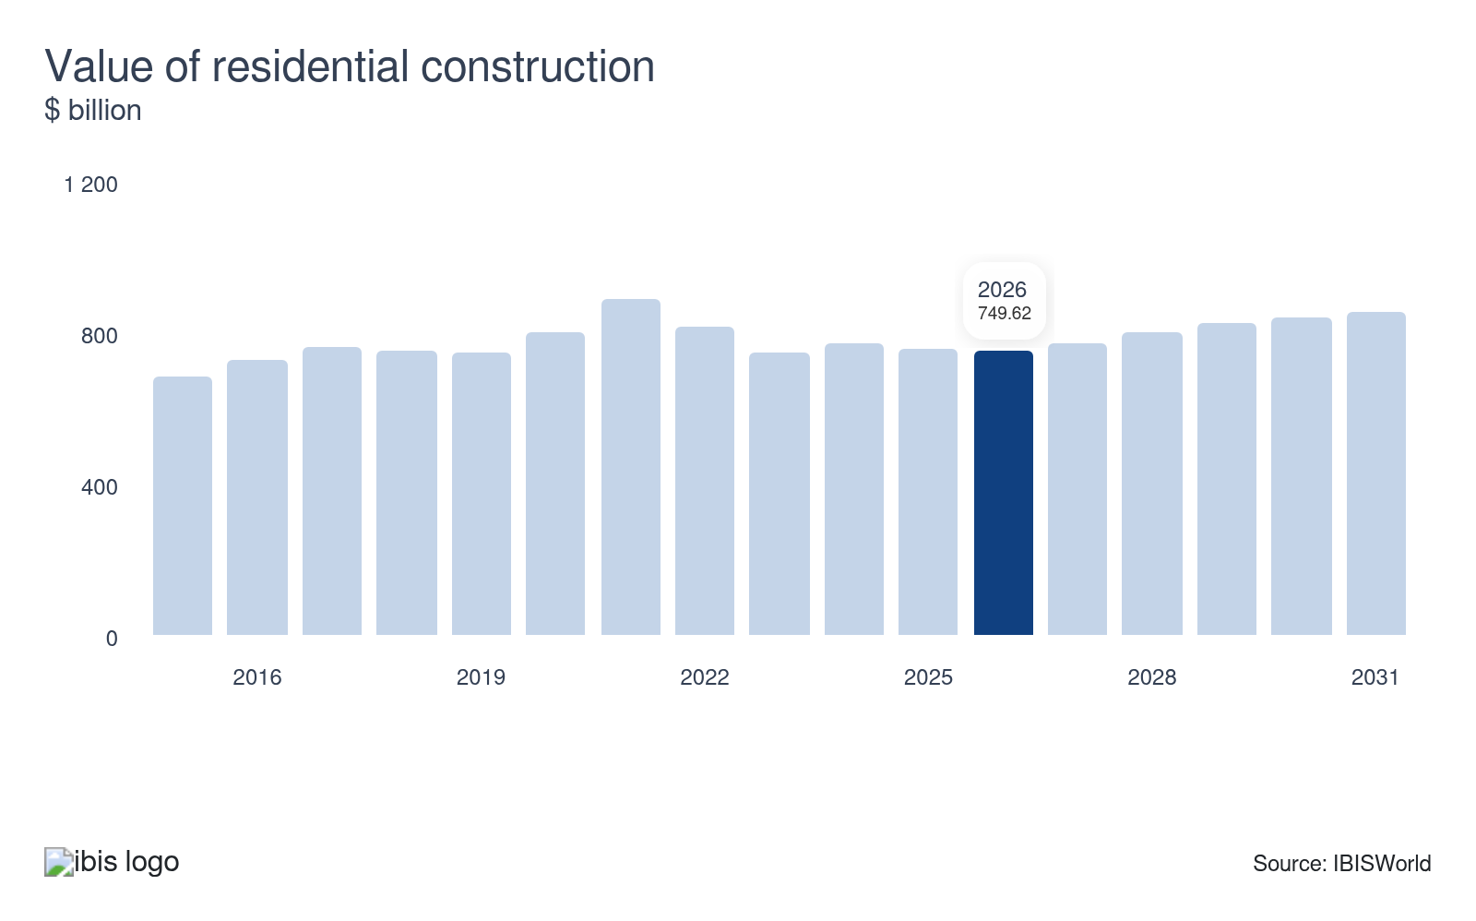
The value of residential construction measures how much capital is spent by businesses and individuals on private residential structures. The level of investment in residential construction influences the demand for numerous services this sector provides, like architecture, landscaping, engineering and interior design. Higher residential valuations strengthen demand for professional and technical services, as clients will have greater fiscal flexibility to pursue residential building alterations and upgrades.
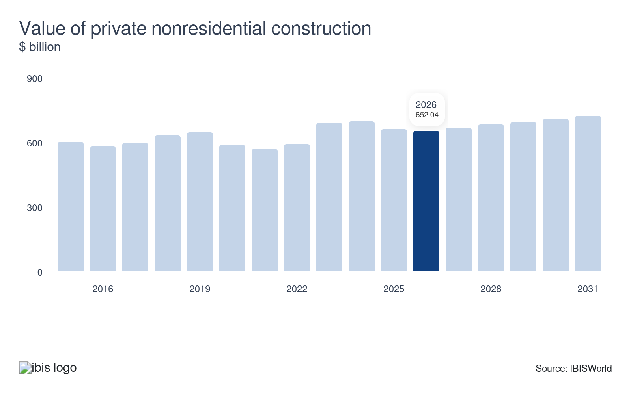
The value of private nonresidential construction measures investment in office buildings, hospitals, factories, power plants, mining shafts and other nonresidential structures. Clients engage the sector’s engineering and architectural services to design and construct nonresidential structures. Slumping nonresidential construction values signal weakness within the corporate sector, forcing servicers to diversify their client base.
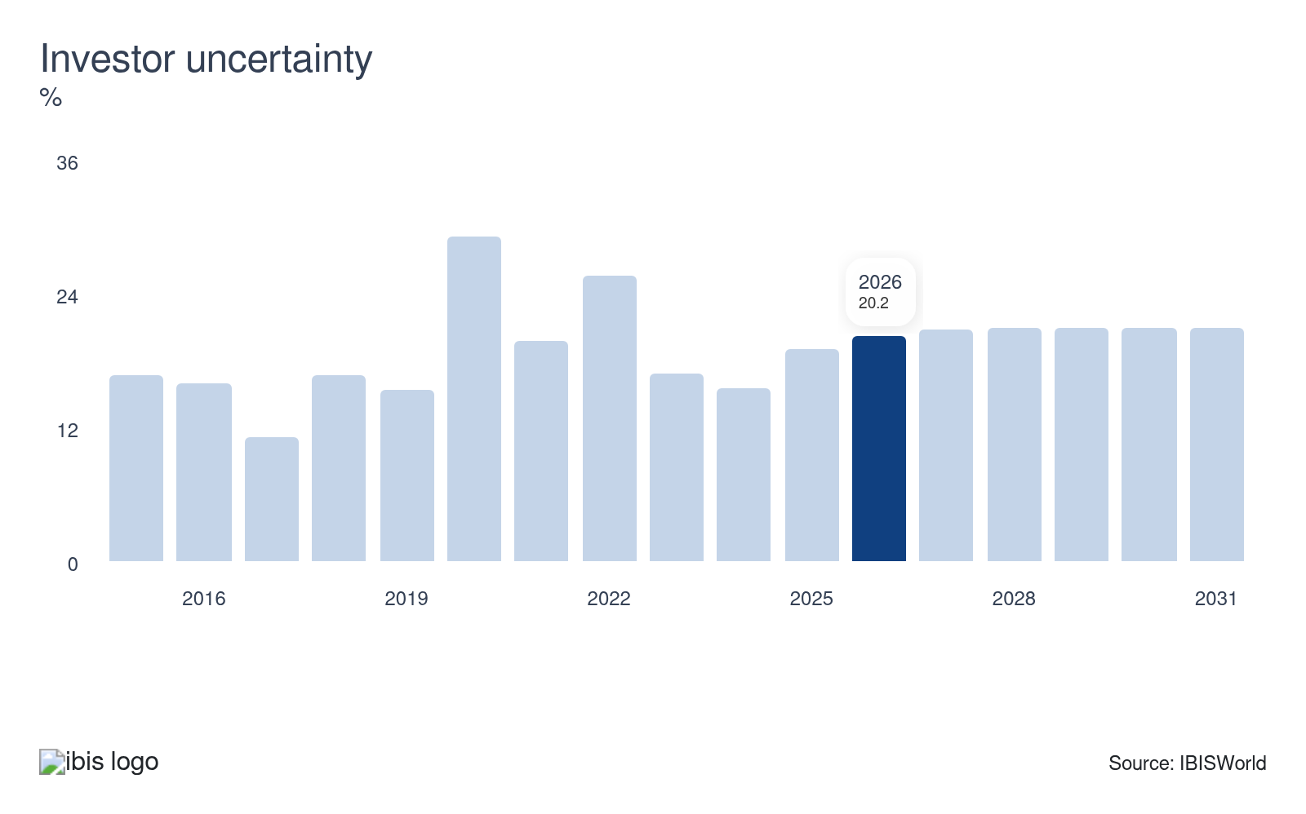
Investor uncertainty, also called the fear index, measures the prices of options contracts on the S&P 500. This metric tends to rise during recessions and contract in booms by affecting investor and business expectation formation. A higher value indicates greater uncertainty and the potential for economic instability, making downstream businesses less willing to invest in services provided by sector companies, posing a potential threat to servicer demand.

Regulation & Policy
Low | Increasing

What regulations impact the industry?

Sarbanes-Oxley Act
The Sarbanes-Oxley Act provides regulatory framework across the corporate management, risk management, auditing and public company financial reporting sectors. Enacted to deter and penalize accounting fraud and corruption, it imposes stringent requirements on financial disclosures and established the Public Company Accounting Oversight Board (PCAOB) to ensure accurate audits were conducted by auditing companies. Although the law governs accounting standards for all publicly traded companies and organizations, most sector regulatory pressure is placed on accounting, bookkeeping and tax preparation service providers. These establishments face rigorous compliance demands, including enhanced internal controls and audit mechanisms.

US Patent and Trademark laws
Many professional and technical service companies are directly affected by US Patent and Trademark laws, which protect intellectual property rights. Advertising and public relations services often negotiate contracts with product companies to market specific brand names with registered trademarks. All patent and trademark oversight is administered by the US Patent and Trademark Office (USPTO), a federal agency that is involved with registering new patents and enforcing IP protections. Patent infringement result in financial fines, while also ensuring that companies can safely innovate and promote their brands without fear of unauthorized use.

Occupational Safety and Health Administration (OSHA)
The Occupational Safety and Health Administration (OSHA) ensures safe working conditions by setting and enforcing rigorous safety standards, particularly for scientific service companies. These regulations include ergonomic requirements to prevent musculoskeletal disorders and guidelines for laboratory safety to mitigate chemical exposure risks, which serve as guidance to ensure employees operate in a safe working environment and clients are protected from potential harm. Service industries involved with harmful materials or chemicals in their offerings, such as scientific research and development (R&D) operators, face the highest regulatory burden from OSHA to ensure worker and customer safety. Failure to adhere to OSHA standards can result in financial penalties and harm a service provider’s national reputation.

Federal Trade Commission (FTC)
The Federal Trade Commission (FTC) provides the blueprint to ensure and enforce truthful and nondeceptive advertising, while also targeting misleading claims that could confuse consumers. The FTC also requires advertisers to provide disclosure statements when there’s potential for consumer misunderstanding. Service providers in the public relations and advertising spaces are most impacted by FTC guidelines. However, companies beyond these two sectors involved in significant marketing campaigns are also impacted by these guidelines, with violations resulting in financial penalties.

Special certifications
Certain professions within the professional, scientific, and technical services sector require special certifications. For instance, individuals looking to enter the accounting sector must pass the Uniform Certified Public Accountant Examination (Uniform CPA Exam) to become certified public accountants (CPAs). Designed by the American Institute of Certified Public Accountants (AICPA) and administered by the National Association of State Boards of Accountancy, this examination ensures that CPAs meet stringent industry standards and deliver efficient professional services to their clients.

Assistance
Low | Steady

What assistance is available to this industry?

Government assistance
Although professional, scientific and technical servicers do not receive direct government assistance, the government does fund scientific research and development companies indirectly. Large agencies, such as the Department of Defense, Environmental Protection Agency, Food and Drug Administration and the US Department of Agriculture procure contracts for development of research & development (R&D) initiatives. Landscape designers also benefit from federal, state and local government-funded projects primarily aimed at construction of new housing. The sector-wide industries most impacted by government assistance involve scientific and technical service industries that work with public and private sector clients.

Software and Information Industry Association (SIIA)
The Software and Information Industry Association (SIIA) aids the technical service sector by offering government relations, business development, corporate education and intellectual property protection. Industries such as the Accounting Services (54121c) industry are very reliant on this association, as they use software programs such as TurboTax to facilitate client services. Companies in the U.S. that produce and deliver software, content products and services benefit from regulatory navigation, enhanced market opportunities and protection of their internal innovations.

Institute of Management Consultants (IMC) USA
The Institute of Management Consultants (IMC) offers professional and technical servicers with professional development opportunities, industry research, legislative monitoring and referrals, among other services. These resources help servicers stay competitive and informed, while also boosting awareness on the latest regulatory changes affecting the consulting market. The IMC also offers certification opportunities for new entrants into the space and networking opportunities across the consulting space. Client-facing industries looking to strengthen their consultation services segments procure assistance from this association to strengthen their background knowledge on the consulting sphere.

Industry-specific associations
Professionals in the professional, scientific and technical services sector receive vital assistance through several key organizations. The American Association of Advertising Agencies provides a code of conduct that guides advertising standards, while Laboratory Testing Services benefit from the National Institute of Standards and Technology's measurement infrastructure. Law firms adhere to standards set by the American Bar Association and the National Lawyers Association. Additionally, architects receive a variety of resources, educational and networking opportunities via the American Institute of Architects.

9. Financial Benchmarks
https://my.ibisworld.com/us/en/industry/54/financial-benchmarks
Profit Margin  23.1 %  ↑ Higher than sector | Average Wage  $88,691  ↑ Higher than sector | Largest Cost  Wages  40.7% of Revenue

Key Takeaways
- Profit remains stagnant. While sector profit has grown due to increased demand, rising wage costs and continued competition across in-house alternatives limited expansive profit growth.
- Wages in the sector remain high due to its service-based nature. A large chunk of professional, scientific and technical servicers’ employees are highly skilled and demand high salaries, particularly within the technological sphere.

Cost Structure
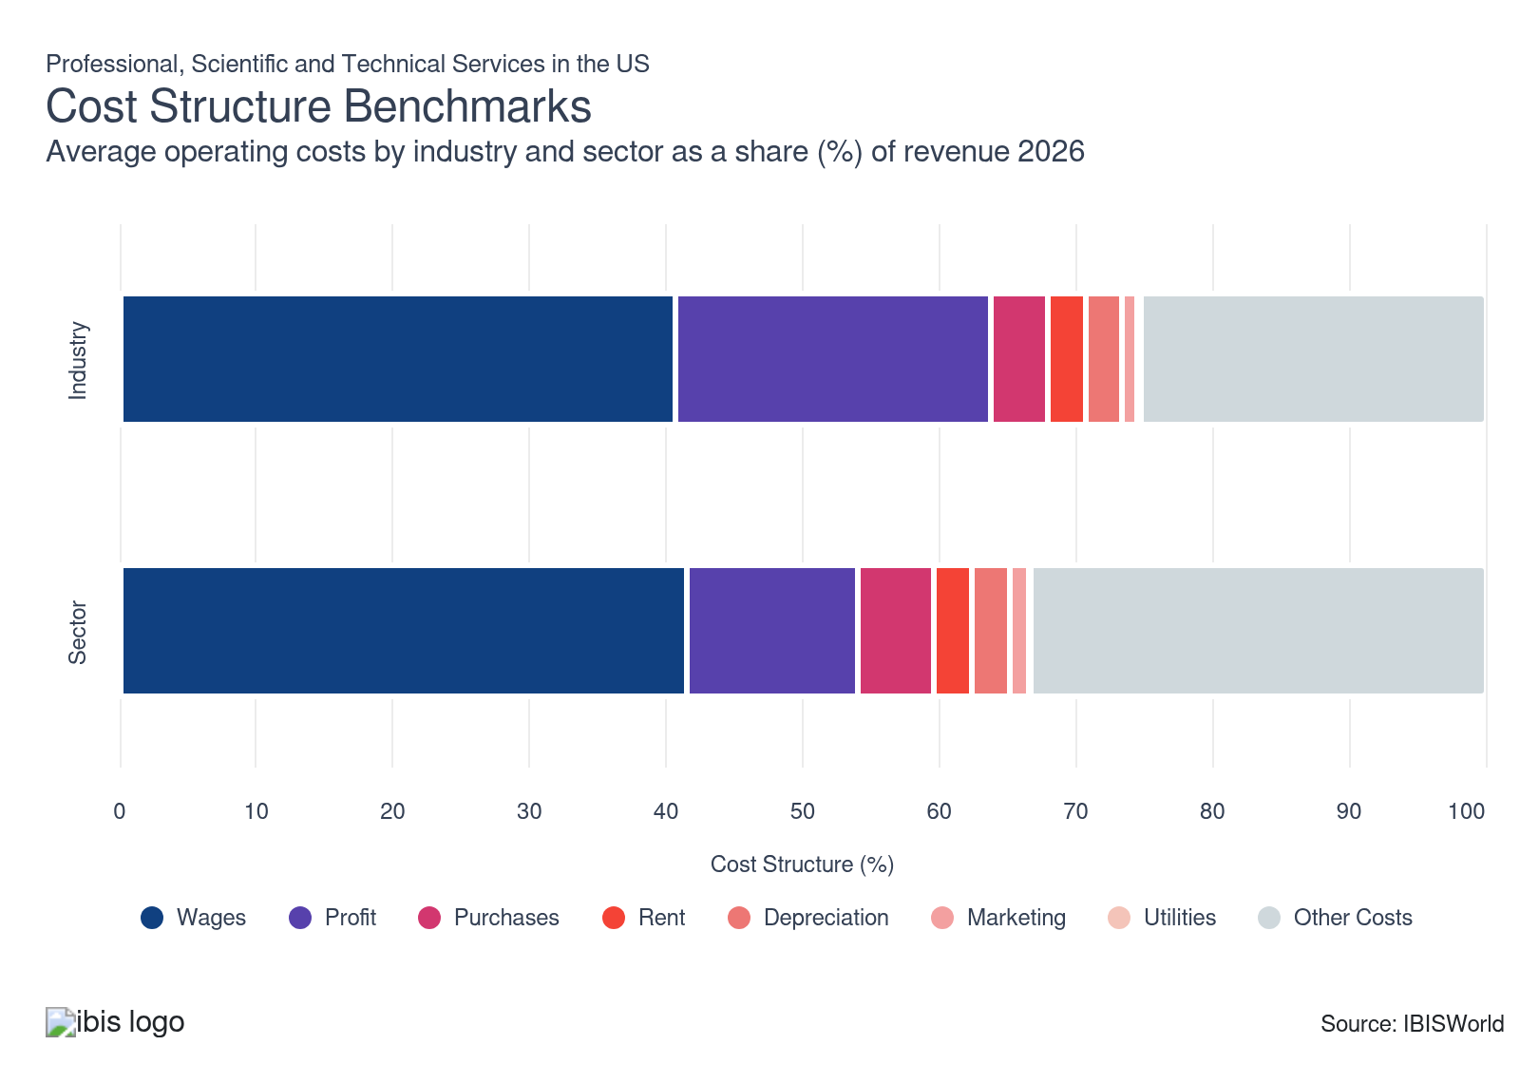
Chart displays current year only in the PDF version of this report. You can view and download chart for all other years associated with this industry on my.ibisworld.com.

What trends impact industry costs?

The labor-intensive nature of the sector and elevated interest rates maintain high wage costs
- Wages make up the largest expenditure across the sector due to high reliance on qualified labor to facilitate efficient client service. Some of the largest wages accrued across the sector are within science and professional service-aligned industries such as the Scientific & Economic Consulting (54169) and Payroll & Bookkeeping Services (54121b).
- The overall sector is labor intensive since employees are highly qualified, highly educated or have developed valuable skills and talents that companies rely on to serve clients. Technical industries pay out higher salaries due to the high educational and technical barriers necessary for employees to break through.
- Despite economic volatility fueled by inflationary spikes in 2022 and current tariff volatility, broader wage expenses have actually slipped over the past five years. The increased use of automation for some lower-skilled jobs across industries such as the Accounting Services (54121c) industry subdued wage growth. Smaller clients like individual customers pivoted to lower-cost DIY alternatives, such as at-home tax preparation software tools.

Profit remains resilient despite macroeconomic upheaval
- Profit, measured as earnings before interest and taxes, remains steady across the sector. Sector-wide profit measures an average across all subindustries and is heavily intertwined on demand for sector services, the current economic environment and operating costs for subindustries.
- Sector industries exhibit relatively different degrees of profitability. For example, profitability for the Law Firms industry (54111) and the Payroll and Bookkeeping Services industry (54121b) is high due to yearly service demand. In comparison, profitability for the Print Advertising Distribution industry (54187) is low because of declining demand for print advertising services.
- Despite a 0.3% boost in the national unemployment rate in 2025, industries have primarily experienced unchanged profitability due to the prevalence and diversified demand for their services. Nonetheless, increasing worker competition have escalated wage costs in niche professional industries, curtailing profit growth in the past year.

Steady use of physical goods maintains consistent purchase costs
- Purchase costs make up a steady expenditure throughout the sector. Companies purchase products and services, which include office supplies, market research and software subscriptions to conduct operations and serve clients efficiently.
- Purchase costs vary depending on the industry and the type of service provided. Industries with greater client-facing service offerings will generate greater purchase costs; for example, Architects’ (54131) purchase costs are 8.1% of collective expenditures, compared to the 10.5% rate of Interior Designers (54141).
- Purchases are also higher in the Direct Mail Advertising industry (54186) because of the need to purchase paper and ink. Science-based industries, such as the Scientific Research & Development industry (54171) accrue higher purchase cost rates due to their robust use of lab equipment and science supplies to facilitate R&D projects.
- Inflationary spikes in 2022 pushed many of the core purchase costs upward for servicers. Companies within the scientific space traditionally generate higher purchase costs compared to other sector verticals due to low substitute prevalence.

Limited use of office space creates stable rental costs
- Rental costs include payments for office space leases and rentals, along with payments for individual facility usage. Some scientific services rent out laboratories to conduct their research or work on niche projects.
- While many professional service industries, such as the Accounting Services (54121c) industry rely on office space to facilitate service with clients, scientific and technical clients are far less reliant on traditional office space, particularly as hybrid work remains popular. According to the BLS, an estimated 39.0% of all sector employees worked remotely in 2023, reducing the need for robust office space.
- Despite interest rate spikes in 2023 accelerating commercial office space costs, sector-wide rental costs have remained stagnant. The growing reliance on hybrid work and shift away from heavy usage of in-person offices allowed many R&D and technical projects to be completed without needing large office spaces.

Reliance on word-of-mouth recommendations curtails robust marketing expenditures
- Marketing costs across the sector primarily entail expenditures for advertising campaigns and promotional efforts when trying to sell a new product or service. Some client-facing industries with limited concentration, such as Interior Designers (54141) rely more on social media campaigns to facilitate greater customer engagement.
- Nonetheless, these costs are extremely limited due to most subindustries relying on word-of-mouth recommendations to facilitate client interest. Satisfied clients have greater propensity to recommend the service to vertical clients, limiting the need for large-scale marketing campaigns.
- Proliferation of digital advertising through mediums such as Instagram and TikTok further diminished the cost of advertising for professional and technical services. Some of the more prominent major companies within industries such as Accounting Services (54121c) use targeted advertising campaigns during tax season, although this is a limited seasonal expenditure.

Limited use of heavy machinery curtails depreciation expenses
- Most depreciation expenses accrued across the sector involve the wear and tear of office equipment and technological tools, such as computers. Some scientific industries that rely on laboratory equipment also face higher depreciation costs compared to professional or technical service industries.
- Nonetheless, depreciation costs are extremely limited, as the overall sector is a client-facing and labor-intensive. There is little to no use of extensive equipment that breaks down quickly, with computer upgrades making up the most expensive, yet infrequent, depreciation cost.
- Even as the sector endured higher use of digital technology and greater volumes across corporate offices, depreciation rates have remained stagnant in the past five years. Greater durability of office furniture and longer-lasting technology makes it unnecessary to invest heavily in frequent equipment upgrades.

Extremely low energy consumption results in extremely low utility expenses
- Utility costs involve payments for various energy supplies, such as electricity, heating, ventilation and air conditioning (HVAC). Since sector-wide industries are client-facing, they consume energy via use of office space and technology, such as computers.
- Utilities make up the smallest expenditure for professional, scientific and technical service industries due to their limited use of energy-intensive equipment and limited reliance on robust offices to provide their services. The most common utility expenditure involves electricity usage.
- Despite sharp swings in electricity prices and the cascading effects of elevated interest rates on sector-wide industries’ expenditures, utility costs remained stagnant. The push to adopt hybrid work curtailed larger office volumes, while adoption of more energy-efficient tools, such as next-generation computers, curtailed energy expenditures.
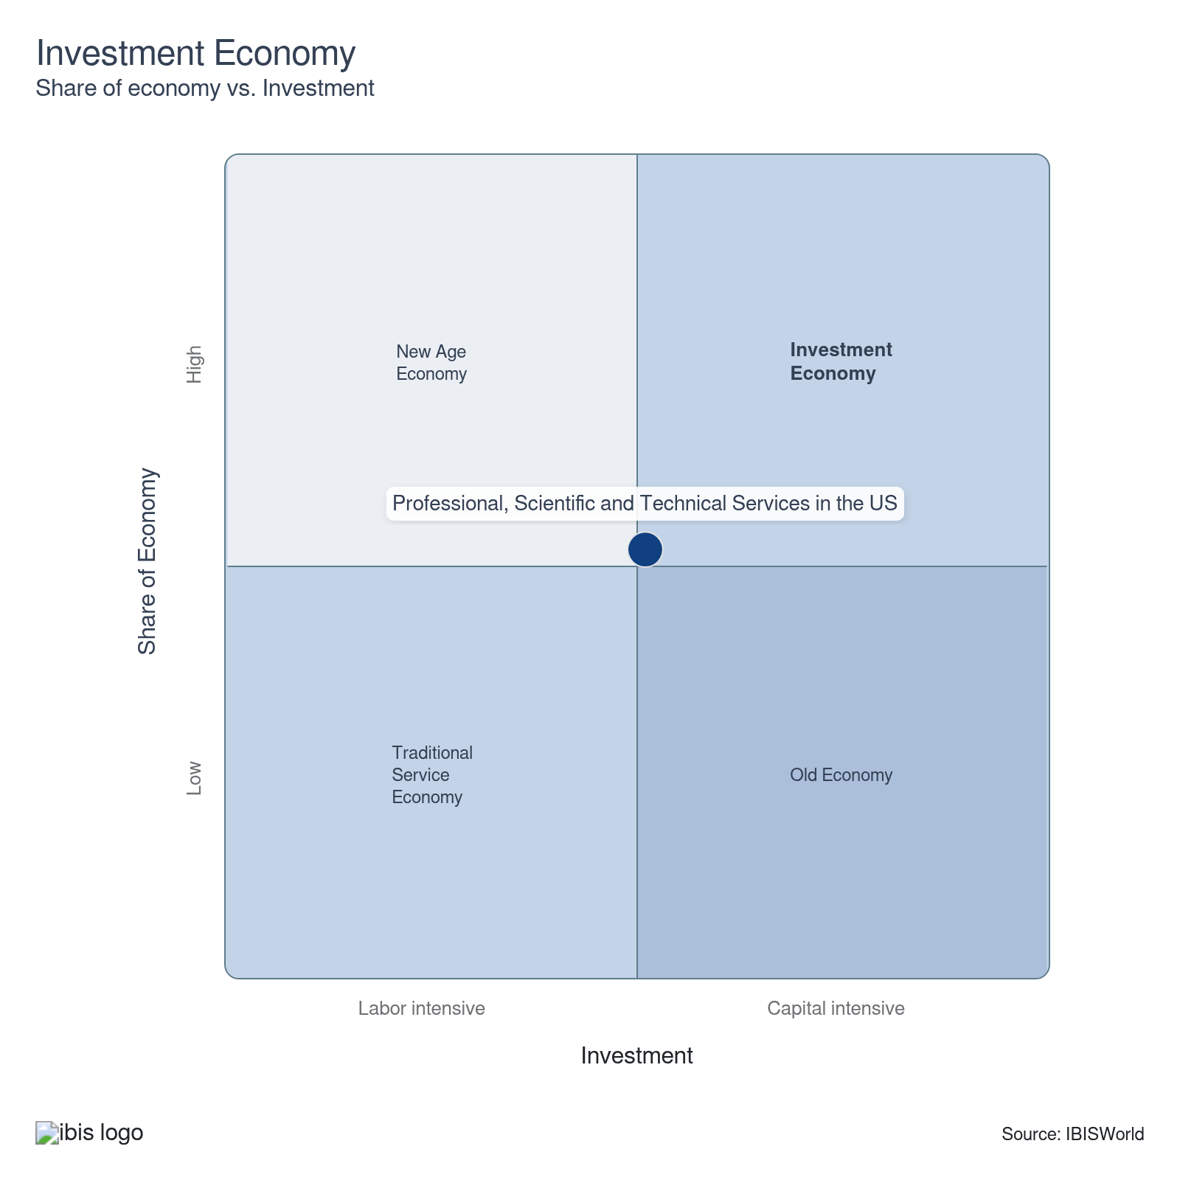

Key Ratios
Year | Revenue per Employee  ($) | Revenue per Enterprise  ($ Million) | Employees per Estab.  (Units) | Employees per Enterprise  (Units) | Average Wage  ($) | Wages/ Revenue  (%) | Estab. per Enterprise  (Units) | IVA/ Revenue  (%)
2005 | 183,201 | 0.5 | 2.9 | 2.9 | 76,708 | 41.9 | 1.0 | 64.0
2006 | 182,773 | 0.5 | 2.9 | 3.0 | 77,849 | 42.6 | 1.0 | 64.8
2007 | 186,002 | 0.5 | 2.9 | 2.9 | 79,247 | 42.6 | 1.0 | 65.2
2008 | 190,660 | 0.6 | 2.9 | 2.9 | 79,495 | 41.7 | 1.0 | 63.8
2009 | 196,947 | 0.6 | 2.8 | 2.8 | 77,684 | 39.4 | 1.0 | 61.0
2010 | 200,812 | 0.6 | 2.8 | 2.8 | 78,973 | 39.3 | 1.0 | 61.9
2011 | 200,808 | 0.6 | 2.8 | 2.8 | 79,924 | 39.8 | 1.0 | 62.9
2012 | 201,529 | 0.6 | 2.8 | 2.8 | 81,293 | 40.3 | 1.0 | 63.2
2013 | 197,697 | 0.6 | 2.8 | 2.9 | 82,122 | 41.5 | 1.0 | 64.1
2014 | 197,386 | 0.6 | 2.8 | 2.9 | 82,257 | 41.7 | 1.0 | 65.6
2015 | 199,136 | 0.6 | 2.8 | 2.9 | 84,609 | 42.5 | 1.0 | 66.4
2016 | 205,977 | 0.6 | 2.8 | 2.9 | 85,197 | 41.4 | 1.0 | 65.5
2017 | 211,891 | 0.6 | 2.8 | 2.9 | 85,303 | 40.3 | 1.0 | 64.7
2018 | 212,488 | 0.6 | 2.8 | 2.8 | 86,793 | 40.8 | 1.0 | 66.6
2019 | 217,033 | 0.6 | 2.8 | 2.8 | 88,337 | 40.7 | 1.0 | 66.6
2020 | 215,260 | 0.6 | 2.9 | 2.9 | 90,496 | 42.0 | 1.0 | 67.3
2021 | 228,186 | 0.6 | 2.8 | 2.8 | 94,253 | 41.3 | 1.0 | 67.2
2022 | 221,414 | 0.6 | 2.8 | 2.9 | 90,555 | 40.9 | 1.0 | 66.6
2023 | 220,620 | 0.6 | 2.9 | 2.9 | 88,914 | 40.3 | 1.0 | 66.1
2024 | 220,586 | 0.6 | 2.9 | 2.9 | 88,914 | 40.3 | 1.0 | 66.1
2025 | 218,714 | 0.6 | 2.8 | 2.9 | 88,763 | 40.6 | 1.0 | 66.3
2026 | 217,860 | 0.6 | 2.8 | 2.9 | 88,691 | 40.7 | 1.0 | 66.4
2027 | 217,837 | 0.6 | 2.8 | 2.9 | 88,689 | 40.7 | 1.0 | 66.3
2028 | 217,694 | 0.6 | 2.8 | 2.9 | 88,678 | 40.7 | 1.0 | 66.4
2029 | 217,382 | 0.6 | 2.8 | 2.9 | 88,652 | 40.8 | 1.0 | 66.4
2030 | 217,389 | 0.6 | 2.8 | 2.9 | 88,653 | 40.8 | 1.0 | 66.4
2031 | 217,450 | 0.6 | 2.8 | 2.9 | 88,658 | 40.8 | 1.0 | 66.4
2032 | 217,472 | 0.6 | 2.8 | 2.9 | 88,660 | 40.8 | 1.0 | 66.4
*Figures are inflation adjusted to 2026
*Figures are inflation adjusted to 2026

10. Key Statistics
https://my.ibisworld.com/us/en/industry/54/key-statistics

Industry Data

Values
Year | Revenue  ($ Million) | IVA  ($ Million) | Estab.  (Units) | Enterprises  (Units) | Employment  (Units) | Wages  ($ Million)
2005 | 1,931,485.8 | 1,235,916.6 | 3,679,726 | 3,610,799 | 10,542,991 | 808,732.3
2006 | 2,002,862.0 | 1,297,789.2 | 3,750,556 | 3,676,108 | 10,958,177 | 853,081.4
2007 | 2,084,801.7 | 1,359,960.0 | 3,896,084 | 3,815,685 | 11,208,469 | 888,241.8
2008 | 2,108,993.3 | 1,345,447.3 | 3,877,004 | 3,800,420 | 11,061,542 | 879,337.3
2009 | 2,148,083.0 | 1,309,911.8 | 3,909,500 | 3,828,532 | 10,906,899 | 847,294.2
2010 | 2,197,646.1 | 1,359,844.9 | 3,972,910 | 3,887,648 | 10,943,821 | 864,263.0
2011 | 2,227,735.3 | 1,401,516.2 | 4,014,869 | 3,929,717 | 11,093,876 | 886,665.8
2012 | 2,262,841.3 | 1,430,293.0 | 4,071,384 | 3,984,887 | 11,228,383 | 912,794.1
2013 | 2,275,742.3 | 1,459,566.6 | 4,105,351 | 4,017,197 | 11,511,256 | 945,329.8
2014 | 2,365,243.4 | 1,552,518.7 | 4,246,044 | 4,153,405 | 11,982,826 | 985,673.3
2015 | 2,431,272.7 | 1,614,781.0 | 4,306,881 | 4,210,841 | 12,209,115 | 1,033,005.1
2016 | 2,521,380.2 | 1,651,989.5 | 4,344,713 | 4,246,924 | 12,241,072 | 1,042,900.2
2017 | 2,636,051.6 | 1,705,049.3 | 4,449,789 | 4,346,391 | 12,440,620 | 1,061,216.7
2018 | 2,727,982.7 | 1,817,281.3 | 4,648,172 | 4,547,780 | 12,838,317 | 1,114,274.7
2019 | 2,833,816.5 | 1,888,569.1 | 4,699,776 | 4,598,166 | 13,057,062 | 1,153,419.1
2020 | 2,850,975.3 | 1,918,946.4 | 4,633,100 | 4,530,433 | 13,244,357 | 1,198,567.3
2021 | 3,049,252.5 | 2,048,957.9 | 4,794,028 | 4,691,760 | 13,363,033 | 1,259,510.1
2022 | 3,136,398.1 | 2,087,670.6 | 4,987,512 | 4,885,514 | 14,165,313 | 1,282,736.9
2023 | 3,193,954.7 | 2,110,547.3 | 5,064,899 | 4,958,099 | 14,477,159 | 1,287,225.3
2024 | 3,267,599.3 | 2,160,893.4 | 5,179,405 | 5,070,163 | 14,813,241 | 1,317,097.5
2025 | 3,259,262.8 | 2,160,707.0 | 5,242,792 | 5,137,383 | 14,901,922 | 1,322,740.3
2026 | 3,284,742.0 | 2,179,598.9 | 5,314,249 | 5,209,500 | 15,077,292 | 1,337,225.1
2027 | 3,348,510.9 | 2,221,620.8 | 5,412,409 | 5,305,549 | 15,371,649 | 1,363,302.7
2028 | 3,415,052.7 | 2,266,170.1 | 5,528,525 | 5,420,125 | 15,687,424 | 1,391,125.8
2029 | 3,475,594.6 | 2,307,015.7 | 5,636,097 | 5,526,353 | 15,988,433 | 1,417,412.4
2030 | 3,536,882.6 | 2,347,008.2 | 5,735,453 | 5,623,852 | 16,269,805 | 1,442,366.7
2031 | 3,601,018.5 | 2,389,816.8 | 5,838,745 | 5,725,223 | 16,560,194 | 1,468,192.8
2032 | 3,661,665.4 | 2,430,208.6 | 5,938,578 | 5,823,353 | 16,837,373 | 1,492,797.4

*Figures are inflation adjusted to 2026

Annual Change
Year | Revenue  % | IVA  % | Estab.  % | Enterprises  % | Employment  % | Wages  %
2005 | N/A | N/A | N/A | N/A | N/A | N/A
2006 | 3.7 | 5.0 | 1.9 | 1.8 | 3.9 | 5.5
2007 | 4.1 | 4.8 | 3.9 | 3.8 | 2.3 | 4.1
2008 | 1.2 | -1.1 | -0.5 | -0.4 | -1.3 | -1.0
2009 | 1.9 | -2.6 | 0.8 | 0.7 | -1.4 | -3.6
2010 | 2.3 | 3.8 | 1.6 | 1.5 | 0.3 | 2.0
2011 | 1.4 | 3.1 | 1.1 | 1.1 | 1.4 | 2.6
2012 | 1.6 | 2.1 | 1.4 | 1.4 | 1.2 | 2.9
2013 | 0.6 | 2.0 | 0.8 | 0.8 | 2.5 | 3.6
2014 | 3.9 | 6.4 | 3.4 | 3.4 | 4.1 | 4.3
2015 | 2.8 | 4.0 | 1.4 | 1.4 | 1.9 | 4.8
2016 | 3.7 | 2.3 | 0.9 | 0.9 | 0.3 | 1.0
2017 | 4.5 | 3.2 | 2.4 | 2.3 | 1.6 | 1.8
2018 | 3.5 | 6.6 | 4.5 | 4.6 | 3.2 | 5.0
2019 | 3.9 | 3.9 | 1.1 | 1.1 | 1.7 | 3.5
2020 | 0.6 | 1.6 | -1.4 | -1.5 | 1.4 | 3.9
2021 | 7.0 | 6.8 | 3.5 | 3.6 | 0.9 | 5.1
2022 | 2.9 | 1.9 | 4.0 | 4.1 | 6.0 | 1.8
2023 | 1.8 | 1.1 | 1.6 | 1.5 | 2.2 | 0.3
2024 | 2.3 | 2.4 | 2.3 | 2.3 | 2.3 | 2.3
2025 | -0.3 | 0.0 | 1.2 | 1.3 | 0.6 | 0.4
2026 | 0.8 | 0.9 | 1.4 | 1.4 | 1.2 | 1.1
2027 | 1.9 | 1.9 | 1.8 | 1.8 | 2.0 | 2.0
2028 | 2.0 | 2.0 | 2.1 | 2.2 | 2.1 | 2.0
2029 | 1.8 | 1.8 | 1.9 | 2.0 | 1.9 | 1.9
2030 | 1.8 | 1.7 | 1.8 | 1.8 | 1.8 | 1.8
2031 | 1.8 | 1.8 | 1.8 | 1.8 | 1.8 | 1.8
2032 | 1.7 | 1.7 | 1.7 | 1.7 | 1.7 | 1.7

*Figures are inflation adjusted to 2026

DISCLAIMER
This product has been supplied by IBISWorld Inc. (‘IBISWorld’) solely for use by its authorized licenses strictly in accordance with their license agreements with IBISWorld. IBISWorld makes no representation to any other person with regard to the completeness or accuracy of the data or information contained herein, and it accepts no responsibility and disclaims all liability (save for liability which cannot be lawfully disclaimed) for loss or damage whatsoever suffered or incurred by any other person resulting from the use of, or reliance upon, the data or information contained herein. Copyright in this publication is owned by IBISWorld Inc. The publication is sold on the basis that the purchaser agrees not to copy the material contained within it for other than the purchasers own purposes. In the event that the purchaser uses or quotes from the material in this publication – in papers, reports, or opinions prepared for any other person – it is agreed that it will be sourced to: IBISWorld Inc.

